TOOLS 2.0 IN LIBRARY ASSOCIATIONS AND NATIONAL LIBRARIES

MLAS Midyear Meeting Report (Feb. 2013)

Author: Glòria Pérez-Salmerón, Director of the Biblioteca Nacional de España
Technical Advisory: Mar Pérez Morillo, Chief of the Web Service at the Biblioteca Nacional de España

Summary
Summary 2
1. Introduction 3
2. Contributions and goals 3
3. Service sustainability 4
4. Management 4
5. Risks 5
5.1 Chaos in management 5
5.2 Controversies 6
6. Platforms features 7
6.1 Facebook 7
6.1.1 Library Associations on Facebook 8
6.1.2 National libraries on Facebook 9
6.1.3 Collaborative sites 10
6.2 Twitter 11
6.2.1 Library associations on Twitter 12
6.2.2 National libraries on Twitter 14
6.2.3 Collaborative sites on Twitter 15
6.3 Other sites 2.0 16
6.3.1 Library associations 16
6.3.2 National libraries 18
6.3.3 Collaborative sites 20
6.3.4 YouTube 21
6.3.5 Flickr 23
6.3.6 Slideshare 26
6.3.7 Blogs 28
6.3.8 Other emergent tools: Pinterest and Linkedin 30
7. The experience of the Biblioteca Nacional de España 36

Introduction
In the frame of the IFLA Management of Library Associations Section (MLAS), a study and analysis is being done about the new ways of communication, especially taking into account the social media environment and its opportunities. Attending the commission of the Standing Committee of MLAS (August 2012 meeting, at Helsinki), the purpose of this report is to review and analyze the presence and use of platforms and sites 2.0 among the most representative library associations, national libraries and other collaborative organizations –like OCLC and Europeana- all over the world.
Since the term “Web 2.0” was coined in 1999 and the social media and the web apps that allowed the interaction with users began to expand, libraries and library associations started using them in a massive way.
The Library and Documentation world soon realized:
- the usefulness of these tools to expand their services,
- the importance of obtaining the users’ feedback and
- the strengths that brought to reach their target.
Data included here have been collected on February, 8th 2013.

Contributions and goals
The steps to take before subscribing an account or profile 2.0 are:
- to define goals
- to ellaborate a strategy to follow
- to evaluate the resources available
- to determine the policy and the terms of use.
The tools 2.0 and social media provide many benefits to libraries and library organizations:
- better dissemination of collections and activities;
- contents are shown in a more dynamic way;
- it’s not the user who encounters the information, but the opposite;
- every user decides what profile or account he is interested in following;
- a more active user participation, who:
  - comments,
  - makes questions,
  - suggests,
  - shares the most interesting content,
  - and even makes requests
- wider extension of online services;
- they broaden the target, bringing the online users in line with the live ones;
- they foster the web traffic between different online channels of the organization;
- they give more visibility to works and projects of organizations and involve the citizens with them.
- they strengthen internal jobs, because they provide user feedback to organization staff. Internally, a way of communication has to be enabled for the staff to apprehend the advantages of these media.

Service sustainability
It is a critical point to take into account the resources available -within every organization- to sustain the service.
Library organizations, such as professional associations and national libraries, need to have it clear from the very beginning that the services they are providing through these platforms must be sustained over time.
Organizational reputation can be seriously damaged if the service they provide ceases.

Management
It must be taken into account that the management and use of these media also affects severely the reputation of the organization. This should not be forgotten.
In this context, many organizations and national libraries are models for others in terms of how they use these tools, as well as how they disseminate their services, projects and collections.
It is strongly recommended that managers have a deep knowledge of the organization, and to the extent possible are members of it.
How to manage these portals will rely on every organization goal.
To properly manage these platforms 2.0 we must:
- know well our users profile;
- be alert to their demands, suggestions or requests;
- closely monitor and handle user comments and their participation;
- update content.
In summary, managers have to be dynamic. And this dynamic management implies the user involvement in such a way as to feel himself part of the organization more directly, not just as a spectator. In such direction the organization has to move.
An essential element for the right management of these channels are the terms of use:
- Internal: in order to keep a consistent policy within the organization, this must have some internal terms of use for platforms 2.0, whether they are generic and of application to all tools or specific and different for each one. This is especially necessary when there is more than one profile or when a profile or account has more than one administrator.
- External: users must know which behavior patterns are set for each channel. Freedom of expression should prevail, but we must also preserve the service that these channels provide, by preventing them from being distorted due to an inappropriate use (spam, insults ...). Therefore, these guidelines should be public and known to all users.
What should be included in these terms of public use for these channels?
- Type of comments and messages not allowed. It should be left clear that no spam, advertising, insults or xenophobic, discriminatory or violence-inciting comments will be tolerated.
- Measures to be taken in case of violation of such rules (deleting comments, blocking recurrent offenders ...).
- Recommendations for use.
Statistics are another key element in the management of these platforms. It is very important that they are analyzed in depth, since they provide an idea on the type of user we have and what their main interests are.

Risks
Being such an active and collaborative channel, along with its many advantages it also poses a number of risks, which we should anticipate and be prepared to manage.

Chaos in management
One of the main risks of this type of channels relates to the possibility of a certain deal of chaos arising in their management, either because
- their objectives are not clear enough,
- no clear terms of use have been set, or
- they are not well known by the administrators of the accounts, profiles and channels.
In order to avoid this,
- There should be a clear general policy regarding behaviour, use and objectives of all 2.0 channels and social media accounts handled by the organization.
- Clear rules for each platform, considering its specific features (Twitter, Facebook, YouTube…).
- Guidelines on behaviour and use for each profile within the same platform, as well as regarding coordination between them (eg. if multiple accounts are maintained in Twitter).
- In case there is more than one administrator for an account, profile or channel, all of them should be fully aware of above and apply regulations in a coordinated way, together with any other staff involved.

Controversies
Another major risk in these channels are the possible controversies that might arise, and publicly shown.
In order to face them up, some basic points are:
- Although it may sound too obvious, the most important thing is to do every possible thing to prevent them from happening. This is often easier than we could expect, if an organized and responsible management is carried out.
- Once the controversy has come up:
  - We should not rush in taking corrective measures to stop it.
  - We should think about the origin of the controversy and analyze why it occurred.
  - Before taking any action, we should consider the mission of the organization, as well as its objectives and what users expect from us.
- Some controversies just turn off spontaneously.
- In others, even users themselves (if already identified with the organization) act as moderators in the controversy.
- If, after studying all aspects involved, it is concluded that the controversy is due to a management error, the organization must give a response.
- Sometimes, a simple apology admitting the error is enough, and it may even reinforce the organization image.

Platforms features
Each channel has its own peculiarities, both in content and user profile. The mission, features and objectives of each association determines the use of a tool or social network instead of the others, as well as the use made of them.

Facebook
It is a very versatile social network. It allows sharing videos, links, image galleries, invitations to an event… And users may leave their comments, or simply state that they like some content, or share content in their own pages.
The follower of an institutional Facebook page has a varied profile. Overall, Facebook allows institutions to reach their remote users in a quite close way.
Content is displayed in a more informal way and advantage should be taken of this, making the user feel more involved in the organization by showing them the work-in-progress behind the projects or the making of events such as exhibitions, or other tasks carried out in the institution but considered from an internal perspective.
Facebook had a peak in expansion about 3 or 4 years ago but its growth has somewhat slowed down mostly if compared to Twitter, which over the last two years has seen a steep increase in followers and use. Perhaps this rise of another social network such as Twitter has also taken followers away from Facebook.
One of the risks posed by Facebook lies in the fact that it requires more control by managers, given that in some cases different profiles and pages are created using the name of the organization but not supported by it, hence leading users to confusion.
Eg. there are 4 pages with the name of Staatsbibliothek zu Berlin: the main one (http://www.facebook.com/#!/Staatsbibliothekzuberlin?fref=ts) and other three
http://www.facebook.com/#!/pages/Staatsbibliothek-zu-Berlin/187342001335559?fref=ts,
http://www.facebook.com/#!/pages/Staatsbibliothek-Berlin/123287574406654?fref=ts
http://www.facebook.com/#!/pages/Staatsbibliothek-zu-Berlin-Haus-Potsdamer-Stra%C3%9Fe/107549909390218?fref=ts

Facebook brings great benefits to the institutions:
- Not only is it a window through which the user communicates with the organization to make inquiries, suggestions or complaints.
- The potential for viral dissemination of content published in this social network is huge. By sharing content, followers of a Facebook page ena
- Traffic is generated from Facebook to other online platforms owned by the institutions (web, Flickr, YouTube, blogs ...).

Library Associations on Facebook

ASSOCIATIONS | Accounts | Followers | Totals
ALA | 15.065
IFLA | IFLA | 3.829 | 4.438
 | LAC | 609
FESABID | 1.609
ABF | 1.482
ANABAD | ANABAD | 1.009 | 1426
 | Castilla-La Mancha | 196
 | Galicia | 112
 | Murcia | 83
 | La Rioja | 26
CILIP | 1.336
EBLIDA | 0
Deutscher Bibliotheksverband |  |  | ------

Facebook pages of library associations:
ALA (American Library Association): http://www.facebook.com/AmericanLibraryAssociation
IFLA (International Federation of Library Associations): http://www.facebook.com/bne#!/pages/IFLA/115229368506017
IFLA LAC (Latin America and the Caribbean Section): http://www.facebook.com/pages/IFLA-LAC/155183447878708
FESABID (Federación Española de Sociedades de Archivística, Biblioteconomía, Documentación y Museística): http://www.facebook.com/pages/Fesabid-p%C3%A1gina/48219917277
ABF (Association des bibliothécaires de France): http://www.facebook.com/abf.associationdesbibliothecairesdefrance?fref=ts
ANABAD (Confederación Española de Asociaciones de Archiveros, Bibliotecarios, Museólogos y Documentalistas): http://www.facebook.com/pages/ANABAD/212949342069288
ANABAD Castilla-La Mancha: http://www.facebook.com/pages/ANABAD-CLM/308789960425
ANABAD Galicia: http://www.facebook.com/pages/ANABAD-Galicia/186568964732868
ANABAD Murcia: http://www.facebook.com/pages/AnabadMurcia/239200212847972
ANABAD La Rioja: http://www.facebook.com/pages/Anabad-La-Rioja/258016314288972
CILIP (Chartered Institute of Library and Information Professionals, UK): http://www.facebook.com/pages/CILIP/119527011399432

National libraries on Facebook

BIBLIOTECAS | Accounts |  | Followers | Totals
Biblioteca Nacional de España | 128.937
Library of Congress | 89.889
British Library | 66.015
BnF | Gallica BnF | 21.984 |  | 43.879
 | BnF | 15.778
 | Bibliothèque numérique des enFants (BnF) | 3.354
 | Classes BnF | 1.043
 | Arlequin – BnF Arts du spectacle | 876
 | Haut-de-jardin (BnF) | 844
National Library of Australia | 4.433
Bayerische Staatsbibliothek | 3.486
Staatsbibliothek zu Berlin | 1.538
Deutsche Nationalbibliothek (Leipzig-Frankfurt) | 1.115
Library and Archives Canada | 401

Facebook pages of national libraries:
Biblioteca Nacional de España: www.facebook.com/bne
Library of Congress: http://www.facebook.com/libraryofcongress
British Library: http://www.facebook.com/britishlibrary
Gallica BnF: http://www.facebook.com/GallicaBnF
BnF: http://www.facebook.com/pages/BnF-Biblioth%C3%A8que-nationale-de-France/298822067879
Bibliothèque numerique des enFants (BnF): http://www.facebook.com/bnfdesenfants
Classes BnF: http://www.facebook.com/lesclassesbnf
Arlequin – BnF Arts du spectacle: http://www.facebook.com/pages/Arlequin-BnF-Arts-du-spectacle/219915681396320
Haut-de-jardin (BnF): http://www.facebook.com/pages/BnF-Haut-de-jardin/125238017487387
National Library of Australia: http://www.facebook.com/National.Library.of.Australia
Bayerische Staatsbibliothek: http://www.facebook.com/BayerischeStaatsbibliothek
Staatsbibliothek zu Berlin: http://www.facebook.com/Staatsbibliothekzuberlin
Deutsche Nationalbibliothek (Leipzig-Frankfurt): http://www.facebook.com/DeutscheNationalbibliothek
Library and Archives Canada: http://www.facebook.com/LibraryArchives

Collaborative sites

PORTALS | Accounts | Followers | Totals
Europeana | 15.484
OCLC | Main | 3.871 | 4.757
 | OCLC Careers | 487
 | OCLC Research | 399

Collaborative sites on Facebook
Europeana: http://www.facebook.com/Europeana
OCLC: http://www.facebook.com/pages/OCLC/20530435726
OCLC Careers: http://www.facebook.com/OCLCCareers
OCLC Research: http://www.facebook.com/OCLCResearch

Twitter
Twitter is a very dynamic social network, which has widely expanded along the past two years. Overall, the profile of its users in the library environment is more professional than in Facebook.
Library organizations long ago discovered how useful this channel was for the dissemination of their services and content. Users of libraries and documentation related organizations were soon on Twitter, and closely following the evolution of this channel.
Another feature is the specialization of the accounts, so that organizations have diversified according to the different audience and subjects. For example, the ALA maintains at least 16 accounts on Twitter, while IFLA has 12. Such segmentation is not so remarkable among national libraries, except for the French National Library and the National Library of Spain (both with 3 Twitter accounts), the rest of the most important libraries only having one. This is the case of the Library of Congress (leader of National libraries in Twitter, with more than 465,000 followers) and the British Library (which is next, with more than 370,000), who prefer to concentrate all his followers into a single corporate account.
When an organization holds more than one account:
- communication or retwitting between the accounts is useful and productive, as it gives a unified image of the institution in front of followers, while encouraging traffic between them.
- it must be clear that target audiences are different and the content distributed through each account must be of specific interest to our followers. For example, followers of the account of the Museum of the National Library on Twitter are particularly interested in all the activities organized by the Museum, while the account of the Director of the BNE in Twitter offers its followers interesting content from the perspective of the person in that position, and her activities as Director. On the other hand, the main account of the BNE has a more general profile, aiming at an audience with a wider range of interests.
It is also the most challenging social network for organizations, since users expect quick responses, and also because it requires very close monitoring.

Library associations on Twitter
ASSOCIATIONS | Accounts |  | Followers | Totals
ALA | @ALALibrary | 29.227 |  | 119.636
 | @amlibraries | 16.668
 | @ALA_TechSource | 11.763
 | @ALA_Booklist | 10.643
 | @ALA_JobLIST | 9.458
 | @alanews | 8.493
 | @ALA_ACRL | 6.805
 | @alaconnect | 4.989
 | @ALA_PLA | 4.750
 | @ALA_RUSA | 3.371
 | @OIF | 3.145
 | @ALALearning | 2.743
 | @ALA_en_espanol | 2.522
 | @oitp | 2.313
 | @alanmrt | 1.468
 | @ALA_Graphics | 1.278
CILIP | @CILIPinfo | 7.572 |  | 10.879
 | @CILIPCKG | 1.340
 | @CILIPWM | 1.011
 | @CILIPRareBooks | 956
IFLA | @IFLA | 4.523 |  | 7.378
 | @IFLA_FAIFE | 896
 | @npsig | 675
 | @IFLA_L2_SIG | 317
 | @IFLA_ALP | 269
 | @ifla2013 | 226
 | @IFLA_GLS | 159
 | @IFLA_LTR | 132
 | @IFLALAC | 69
 | @IFLA_MCULTP | 54
 | @IFLACPDWL | 38
 | @IFLA_WIL | 20
FESABID | @fesabid | 3.283 |  | 4.114
 | @Fesabid_BPI | 831
ANABAD | @Anabad_Galicia | 521
ABF | @abf_info | 323
EBLIDA | ------
DBV (Deutscher Bibliotheksverband) | ------

Twitter accounts of library associations:
ALA Library: https://twitter.com/ALALibrary
American Libraries (ALA): https://twitter.com/amlibraries
ALA TechSource: https://twitter.com/ALA_TechSource
ALA Booklist Pubs: https://twitter.com/ALA_Booklist
JobLIST Library Jobs (ALA): https://twitter.com/ALA_JobLIST
ALA News: https://twitter.com/alanews
ALA Association of College and Research Libraries: https://twitter.com/ALA_ACRL
ALA Connect: https://twitter.com/alaconnect
ALA Public Library Association: https://twitter.com/ALA_PLA
ALA Reference and User Services Association (RUSA): https://twitter.com/ALA_RUSA
ALA Office for Intellectual Freedom: https://twitter.com/OIF
ALA Learning: https://twitter.com/ALALearning
ALA en español: https://twitter.com/ALA_en_espanol
ALA Office for Information Technology Policy: https://twitter.com/oitp
ALA New Members Round Table: https://twitter.com/alanmrt
ALA Graphics: https://twitter.com/ALA_Graphics
CILIP (Chartered Institute of Library and Information Professionals): https://twitter.com/CILIPInfo
The CILIP Carnegie & Kate Greenaway Children's Book Awards: https://twitter.com/CILIPCKG
CILIP West Midlands: https://twitter.com/CILIPWM
CILIP Rare Books: https://twitter.com/CILIPRareBooks
IFLA: https://twitter.com/IFLA
IFLA Free Access to Information and Freedom of Expression Committee (FAIFE): https://twitter.com/IFLA_FAIFE
IFLA New professionals: https://twitter.com/npsig
IFLA Library 2.0 Special Interest Group: https://twitter.com/IFLA_L2_SIG
IFLA ALP, Building Better Library Communities: https://twitter.com/IFLA_ALP
IFLA 2013: https://twitter.com/ifla2013
IFLA Gov Lib Section: https://twitter.com/IFLA_GLS
IFLA Library Theory and Research Section: https://twitter.com/IFLA_LTR
IFLA Latin America and the Caribbean Section: https://twitter.com/IFLALAC
IFLA Library Services to Multicultural Populations Section: https://twitter.com/IFLA_MCULTP
IFLA Continuing Professional Development and Workplace Learning Section: https://twitter.com/IFLACPDWL
IFLA Women, Information & Libraries: https://twitter.com/IFLA_WIL
FESABID: https://twitter.com/fesabid
FESABID Grupo de Profesionales de Bibliotecas y Propiedad Intelectual: https://twitter.com/Fesabid_BPI
ANABAD Galicia: https://twitter.com/Anabad_Galicia
ABF (Association des bibliothécaires de France): https://twitter.com/abf_info

National libraries on Twitter
LIBRARIES | Accounts |  | Followers | Totals
Library of Congress | @librarycongress |  | 468.756
The British Library | @britishlibrary |  | 375.357
Biblioteca Nacional de España | @BNE_biblioteca | 15.328 |  | 20.140
 | @BNE_Museo | 3.515
 | @BNE_Directora | 1.297
Bibliothèque nationale de France | @GallicaBnF | 12.035 |  | 15.807
 | @LaboBnF | 3.177
 | @DLWebBnF | 595
National Library of Australia | @nlagovau |  | 9.483
Library and Archives Canada | @LibraryArchives | 2.145
Bayerische Staatsbibliothek | @bsb_muenchen | 1.111
Staatsbibliothek zu Berlin | @sbb_news | 948
Deutsche Nationalbibliothek (Leipzig-Frankfurt) | @DNB_Aktuelles | 203

Twitter accounts of national libraries:
Library of Congress: https://twitter.com/librarycongress
The British Library: https://twitter.com/britishlibrary
Biblioteca Nacional de España: https://twitter.com/BNE_biblioteca
Museo de la Biblioteca Nacional de España: https://twitter.com/BNE_Museo
Directora de la Biblioteca Nacional de España: https://twitter.com/BNE_Directora
BnF Gallica: https://twitter.com/GallicaBnF
BnF The Labo: https://twitter.com/LaboBnF
Dépôt legal Web BnF: https://twitter.com/DLWebBnF
National Library of Australia: https://twitter.com/nlagovau
Library and Archives Canada: https://twitter.com/LibraryArchives
Bayerische Staatsbibliothek: https://twitter.com/bsb_muenchen
Staatsbibliothek zu Berlin: https://twitter.com/sbb_news
Deutsche Nationalbibliothek (Leipzig-Frankfurt): https://twitter.com/DNB_Aktuelles

Collaborative sites on Twitter
PORTALS | Accounts |  | Followers
OCLC | @OCLC | 9.219 | 10.864
 | @oclcdevnet | 657
 | @OCLC_ANZ | 362
 | @OCLC_NL | 214
 | @OCLCMemServ | 210
 | @OCLC_DE | 90
 | @oclccareers | 65
 | @oclcinnovation | 47
Europeana | @europeanaeu | 8.576 | 9.411
 | @EuropeanaTech | 583
 | @wikieuropeana | 252

Twitter accounts of collaborative sites:
OCLC: https://twitter.com/OCLC
OCLC Developer Network: https://twitter.com/oclcdevnet
OCLC Australia and New Zealand: https://twitter.com/OCLC_ANZ
OCLC Nederland: https://twitter.com/OCLC_NL
OCLC Member Services: https://twitter.com/OCLCMemServ
OCLC Deutschland: https://twitter.com/OCLC_DE
OCLC Careers: https://twitter.com/oclccareers
OCLC Innovation: https://twitter.com/oclcinnovation
Europeana: https://twitter.com/europeanaeu
Europeana Tech Research and Development community: https://twitter.com/EuropeanaTech
Wiki plus Europeana: https://twitter.com/wikieuropeana

Other sites 2.0
ASSOCIATIONS | YOUTUBE | FLICKR | SLIDESHARE |  |  | BLOGS
 | Views | Photos | Channels | Presentations | Totals | Nr. of blogs
ALA | 366.064 | ------ | Principal | 26 | 67 | 19
 |  |  | Otro | 4
 |  |  | ALA LLAMA | 37
Deutscher Bibliotheksverband | 32.216 | ------ | ------ |  |  | 1
CILIP | 17.560 | 362 | ARLG | 21 | 287 | 23
 |  |  | SLIC | 264
 |  |  | Midlands & Anglia | 2
IFLA | 6.738 | 2.615 | IFLA New Professionals Special Interest Group |  | 21 | 25
FESABID | ------ | 1.056 |  |  | 195 | 1
ANABAD | ------ | ------ | ------ |  |  | 2
EBLIDA | ------ | ------ | ------ |  |  | 1
ABF | ------ | ------ | Hybrides | 21 | 26 | ------
 |  |  | Rhône-Alpes | 2
 |  |  | ABF | 3

Library associations

YouTube channels of library associations:
ALA: http://www.youtube.com/user/amlibraryassociation
Deutscher Bibliotheksverband: http://www.youtube.com/user/dbvbibliothekskanal
CILIP: http://www.youtube.com/user/cilipmarketing
IFLA: http://www.youtube.com/user/iflahq

Flickr channels of library associations:
CILIP: http://www.flickr.com/photos/cilippprg/
IFLA: http://www.flickr.com/photos/ifla/
FESABID: http://www.flickr.com/photos/fesabid/

Slideshare channels of library associations:
ALA: http://www.slideshare.net/ALAhq y http://www.slideshare.net/ALAadmin
ALA Library Leadership and Management Association: http://www.slideshare.net/LLAMA_ALA
CILIP Scottish Library and Information Council: http://www.slideshare.net/scottishlibraries
CILIP Academic and Research Libraries Group: http://www.slideshare.net/ciliparlg
CILIP Midlands and Anglia LSG: http://www.slideshare.net/MALSG
IFLA New Professionals Special Interest Group: http://www.slideshare.net/npsig
FESABID: http://www.slideshare.net/fesabid
ABF: http://www.slideshare.net/abfabf
ABF Hybrides: http://www.slideshare.net/abfbib
ABF Rhone-Alpes: http://www.slideshare.net/ABFRhonealpes

Blogs of library associations:
ALA: http://www.ala.org/Template.cfm?Section=News&template=/cfapps/xml/pr_inst.html
Deutscher Bibliotheksverband: http://www.bibliotheksverband.de/blog/
CILIP: http://communities.cilip.org.uk/blogs/bloggers.aspx
IFLA: http://blogs.ifla.org/
FESABID: http://www.fesabid.org/titulares
ANABAD: http://anabadlarioja.blogspot.com.es/ y http://anabadaragon.blogspot.com.es/
EBLIDA-NAPLE: http://napleblog.wordpress.com/2012/05/24/eblida-naple-conference/

National libraries
NATIONAL LIBRARIES | YOUTUBE |  |  | FLICKR |  |  | SLIDESHARE | BLOGS
 | Channels | Views | Totals | Channels | Photos | Totals | Presentations | Nr. of blogs
Library of Congress | 4.487.125 |  |  | 17.727 |  |  | ------ | 10
British Library | British Library Business & IP Centre | 377.345 | 516.401 | 72 |  |  | 2 | 20
 | The British Library | 139.056
Biblioteca Nacional de España | 470.872 |  |  | 754 |  |  | 93 | 1
National Library of Australia | 360.816 |  |  | NLA | 32 | 443 | 38 | 5
 |  |  |  | NLA Commons | 411
Bayerische Staatsbibliothek | 13.698 |  |  | ------ |  |  | ------ | ------
Bibliothèque nationale de France | 12.388 |  |  | ------ |  |  | ------ | 7
Deutsche Nationalbibliothek | 6.119 |  |  | ------ |  |  | ------ | ------
Library and Archives Canada | 5.459 |  |  | 2.328 |  |  | ------ | 1
Staatsbibliothek zu Berlin | 157 |  |  | ------ |  |  | ------ | ------

YouTube channels of national libraries:
Library of Congress: http://www.youtube.com/user/libraryofcongress
British Library Business and IP Centre: http://www.youtube.com/user/bipctv
The British Library: http://www.youtube.com/user/britishlibrary
Biblioteca Nacional de España: www.youtube.com/bibliotecabne
National Library of Australia: http://www.youtube.com/user/wwwnlagovau
Bayerische Staatsbibliothek: http://www.youtube.com/user/baystaatsbibliothek
Bibliothèque nationale de France: http://www.youtube.com/user/bibliothequebnf
Deutsche Nationalbibliothek: http://www.youtube.com/user/dtnationalbibliothek
Library and Archives Canada: http://www.youtube.com/user/libraryarchivecanada
Staatsbibliothek zu Berlin: http://www.youtube.com/channel/UC80a6lES-lq7pBjCk3eEHtQ

Flickr channels of national libraries:
Library of Congress: http://www.flickr.com/photos/library_of_congress/
The British Library: http://www.flickr.com/photos/britishlibrary
Biblioteca Nacional de España: http://www.flickr.com/photos/bibliotecabne/
National Library of Australia: http://www.flickr.com/photos/national_library_of_australia_commons/ y http://www.flickr.com/photos/national_library_of_australia/
Library and Archives Canada: http://www.flickr.com/photos/lac-bac/

Slideshare channels of national libraries:
Datasets at the British Library: http://www.slideshare.net/DatasetsBL
Biblioteca Nacional de España: http://www.slideshare.net/bne
National Library of Australia: http://www.slideshare.net/natlibraryofaustralia

Blogs of national libraries:
Library of Congress: http://blogs.loc.gov/
British Library: http://www.bl.uk/blogs/
BnF: http://blog.bnf.fr/
National Library of Australia: http://blogs.nla.gov.au/
Library and Archives Canada: http://thediscoverblog.com/

Collaborative sites
PORTALS | YOUTUBE |  |  | FLICKR | SLIDESHARE |  |  | BLOGS
 | Accounts | Views | Totals | Photos | Channels | Presentations | Totals | Nr. of blogs
OCLC | Video Channel | 38.581 | 51.243 | ------ | Research | 60 | 164 | 11
 |  |  |  |  | Research (Programs) | 74
 | Research Channel | 13.683 |  |  | LAC | 14
 |  |  |  |  | Question Point | 16
Europeana | 7.888 |  |  | 7.829 | 1.046 |  |  | 1

YouTube channels of collaborative sites:
OCLC Video: http://www.youtube.com/user/oclcvideo
OCLC Research: http://www.youtube.com/user/oclcresearch
Europeana: http://www.youtube.com/user/europeanaeu

Flickr channels of collaborative sites:
Europeana: http://www.flickr.com/photos/europeanaimages2/

Slideshare channels of collaborative sites:
OCLC Research: http://www.slideshare.net/oclcr y http://www.slideshare.net/RLGPrograms
OCLC LAC: http://www.slideshare.net/OCLCLAC
OCLC Question Point: http://www.slideshare.net/QuestionPoint
Europeana: http://www.slideshare.net/EuropeanaRegia

Blogs of collaborative sites:
OCLC: http://www.oclc.org/us/en/community/talk/blogs/default.htm
Europeana: http://blog.europeana.eu/

YouTube
Many organizations have also opened channels on YouTube to broadcast videos on their activities.
Some of them have more than one channel on this platform, such as the OCLC or the British Library. Other organizations upload their videos into YouTube, but they do not have a corporate channel.
From libraries’ perspective, this channel allows to spread videos on:
- the organization’s activities (technical process, binding…)
- events held (exhibitions, conferences…)
- documentary collections (Cartography, Engravings…)
- historical audiovisuals (origins of the institution…)
In some cases, such as for the Library of Congress, it also serves as an audiovisual digital repository and helps disseminate historical audiovisual content, eg. the playlist with the first films by the Edison Company (http://www.youtube.com/watch?v=daKHH7AdN8U&list=ECD28424FAA9414F49) or by Westinghouse in 1904 (http://www.youtube.com/course?list=ECF6836E1FFAEE6AC1).

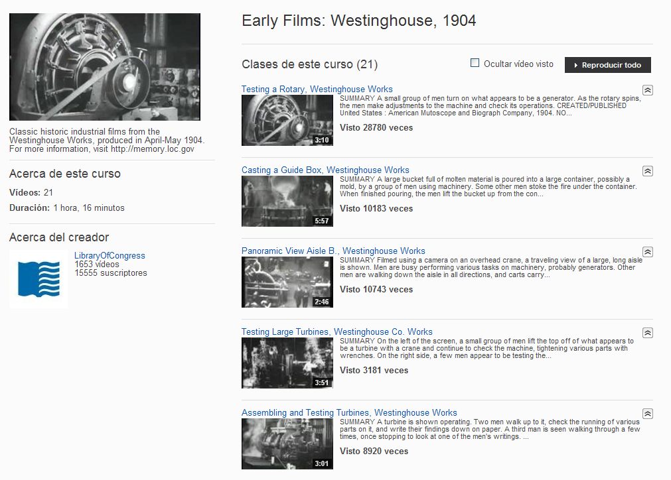

Creating playlists is very helpful for users, since the material offered by the channel may be grouped thus making navigation easier.

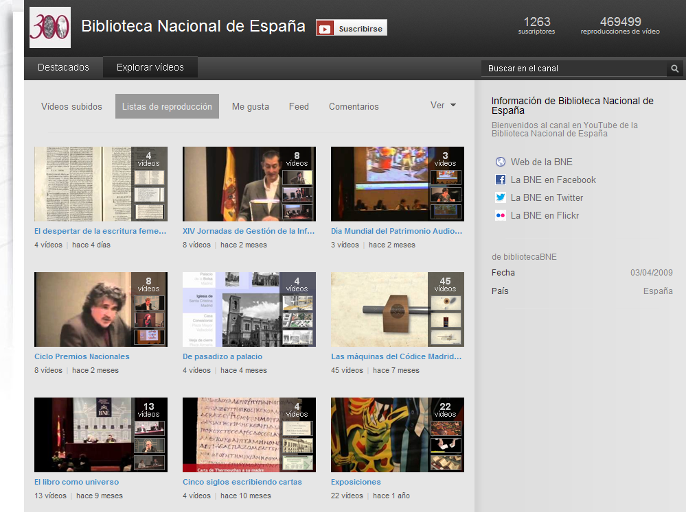

Flickr
Flickr allows to create collections of images, mostly photographs (http://www.flickr.com/photos/lac-bac/sets/72157631684420843/).

But also other types of graphic materials, such as posters (http://www.flickr.com/photos/library_of_congress/sets/72157628703260971/).

This platform is less extensively used by library associations, but quite popular among libraries, and not only national, but also university libraries. It is a particularly useful tool to disseminate library collections, although albums with photographs of events and professional meetings are also showcased (see examples on IFLA Flickr portal, http://www.flickr.com/photos/ifla/sets/72157631206810090/).

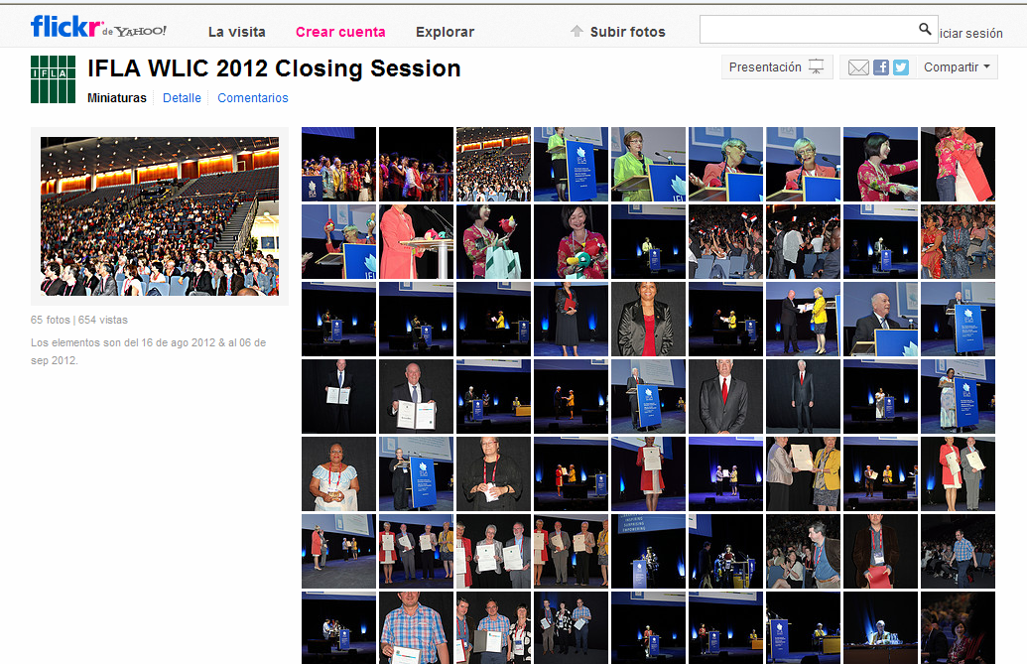

Among the major library associations, only IFLA and CILIP FESABID have a Flickr account. IFLA is the one with the highest number of files hosted on this platform, with over 2,500 images.

As for national libraries, the Library of Congress also holds leadership in Flickr, with more than 17,000 images (http://www.flickr.com/photos/library_of_congress/).

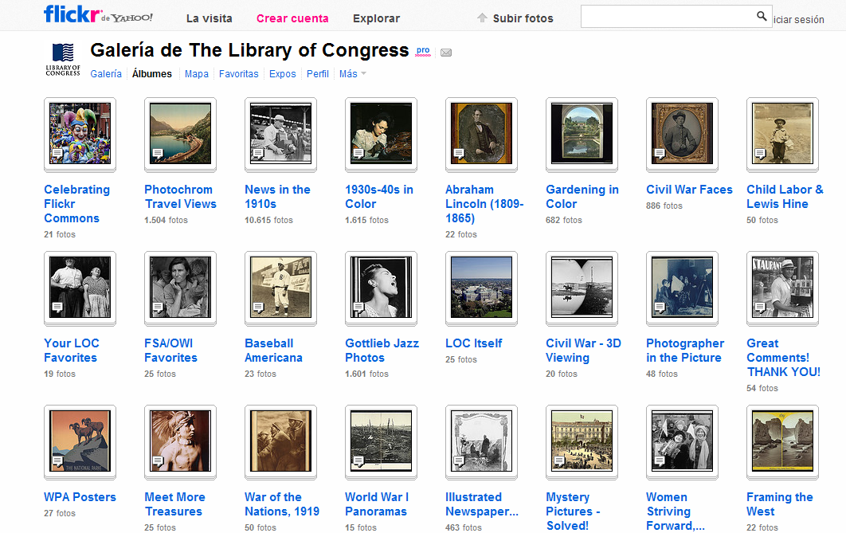

The Library of Congress is far behind followed by the Library and Archives of Canada and Europeana. The latter, though not being a national library, is considered in the present document within the same category, as an aggregator of digital collections from European national libraries.
As shown by the tables below, only three of the library associations studied here (see § 8.3), versus 6 national libraries (see § 9.3), have Flickr accounts.

Slideshare
Slideshare is a portal for sharing presentations. Library organizations have discovered its potential to disseminate their documents - not only the works carried out by their specialized staff, but also those presented in conferences and meetings.

In using this portal, library associations clearly surpass libraries. Out of the 9 associations studied in this report, 6 have accounts on Slideshare, while 4 of these 6 have more than 3 channels on the platform.

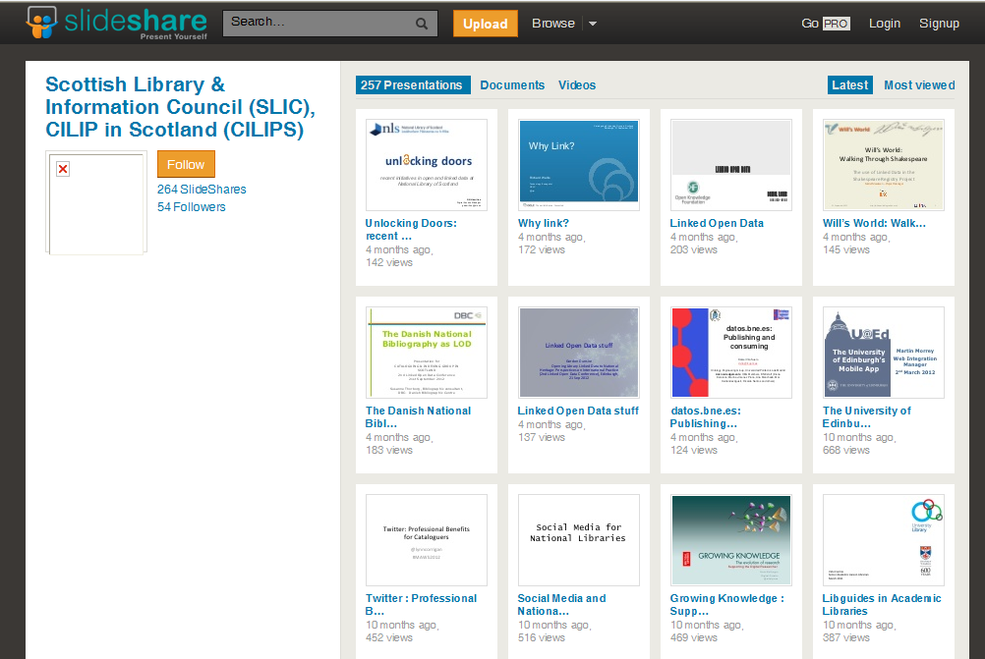

But among national libraries it still has been implemented only to a minor extent. Only 4 out of the 10 included in this report have Slideshare channels. The National Library of Spain stands out here, with 93 presentations in the channel.

It should be mentioned, however, that it is widely used by individual library and documentation professionals for uploading their presentations and papers, without having to include them in a corporate channel.

Blogs
Blogs are one of the 2.0 tools most widely used by library organizations of all kinds, both professional associations and libraries. A blog is a very versatile platform to publish articles for a specialized audience or aimed at disseminating a wide range of topics of interest to professionals and users.
Both professional associations and national libraries usually have more than one blog, since they have become more and more specialized by subject: school libraries, information technology, bibliography, preservation and conservation, maps, medieval manuscripts, music, web files, performing arts… IFLA leads library associations in number of blogs, with 25 (http://blogs.ifla.org/).

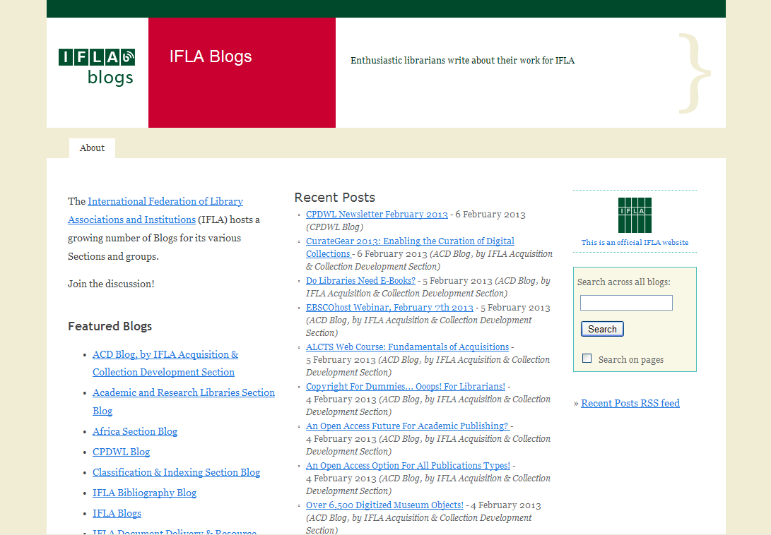

…and the British Library holds first position among national libraries, with 20 different blogs (http://www.bl.uk/blogs/).

Other emergent tools: Pinterest and Linkedin
Among the fastest-growing social networks over recent times, Pinterest and Linkedin are the most outstanding.
Pinterest is a website for photo sharing where users create and manage collections of images based on different topics or events.
Some important libraries are beginning to join this social network, which appears to be an interesting dissemination tool, especially for those with graphic collections. The British Library or Gallica, the digital library of the BnF, have Pinterest accounts.

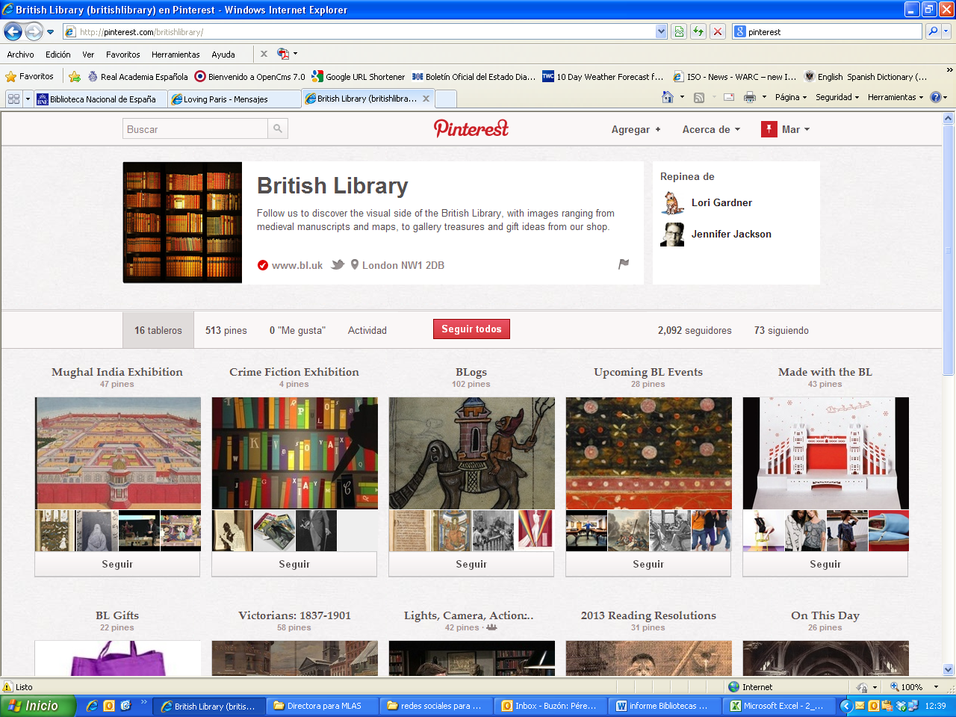

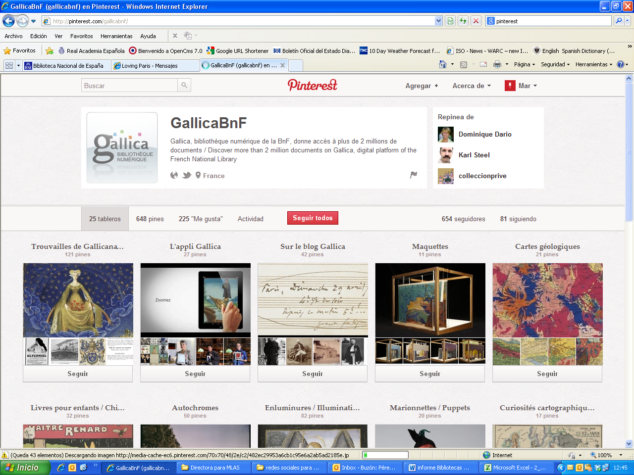

Some library associations have also created accounts on this platform. Such is the case of the American Libraries Magazine:

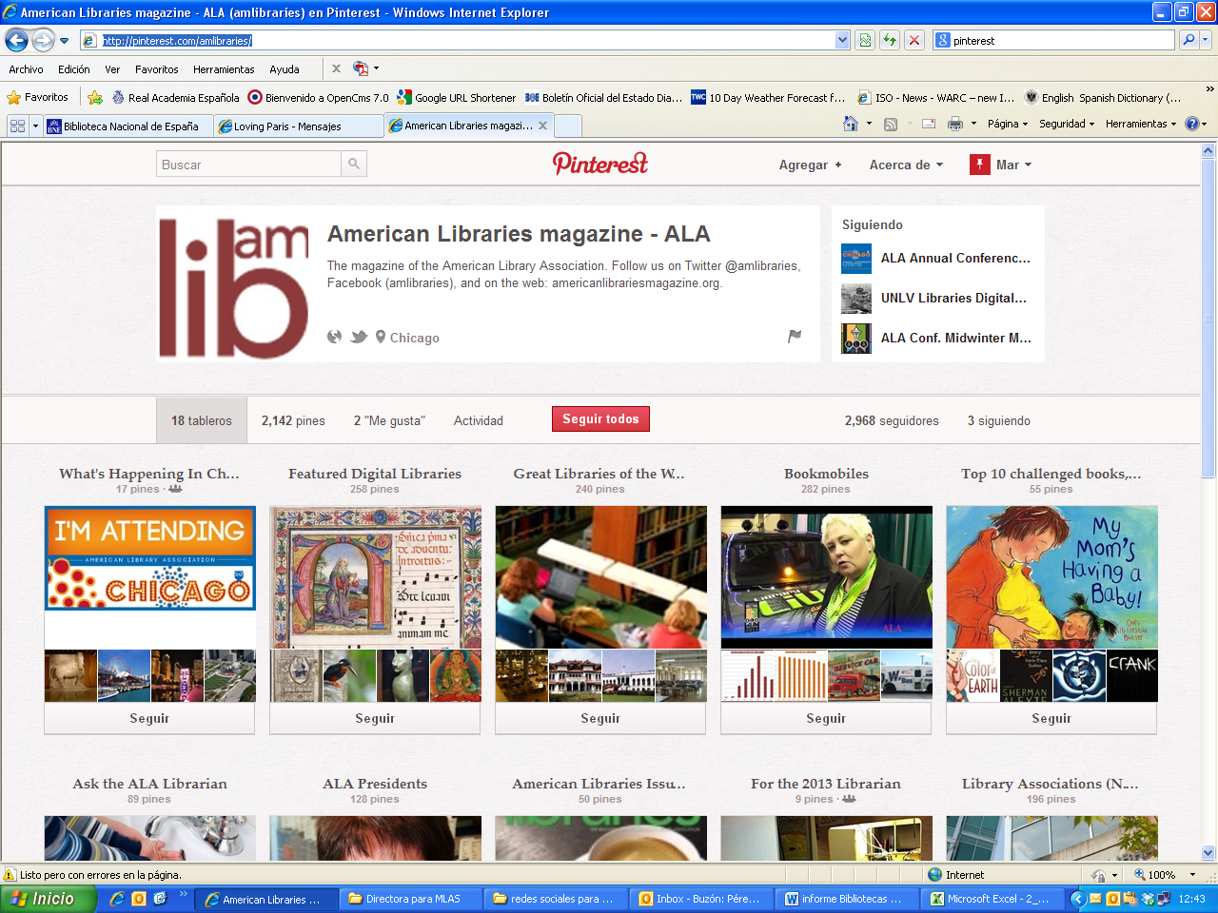

Or the IFLA’s New Professionals Special Interest Group:

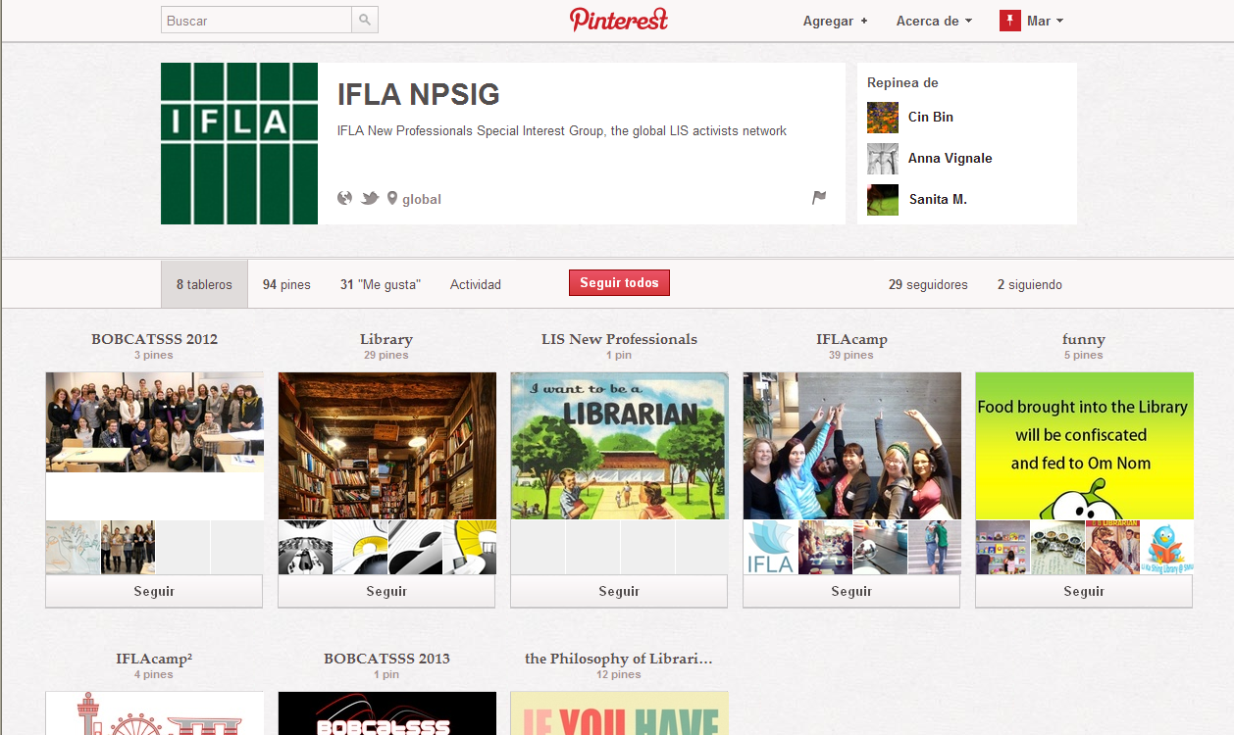

Another expanding social network is LinkedIn. This is a professional platform through which professionals from all fields get into contact. Also libraries and library associations are increasing their presence in LinkedIn. Being a more specialized network, it is easy to find professional subgroups.

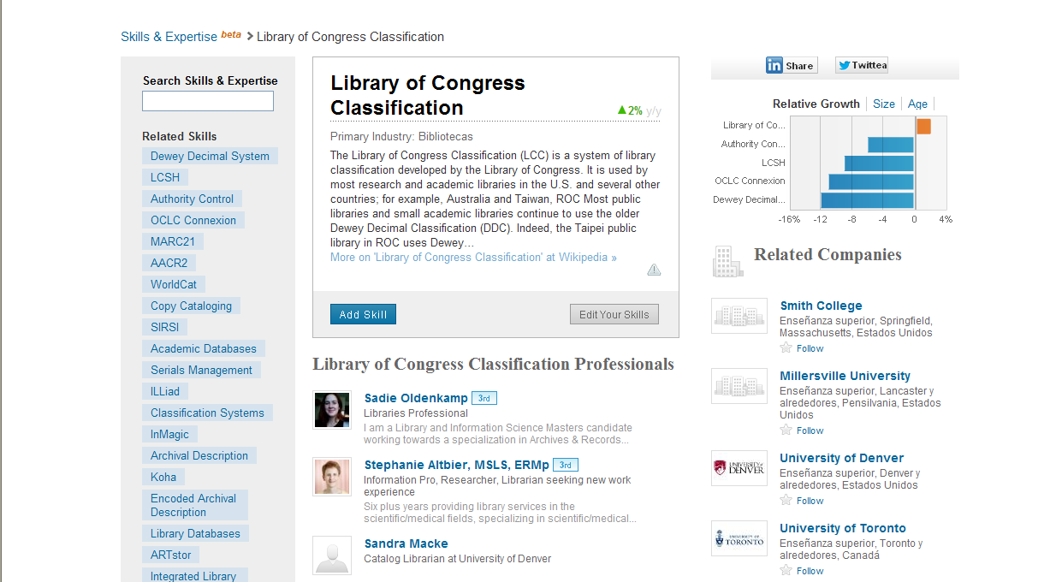

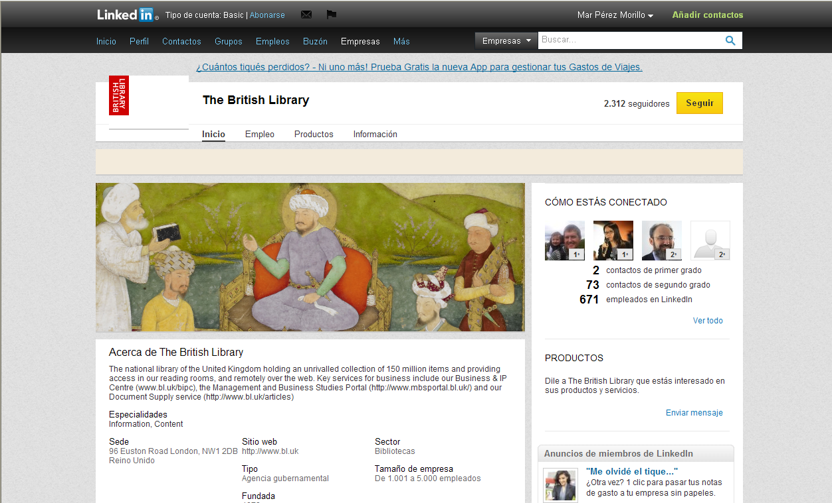

This social network is particularly useful for library associations, as it allows and encourages the exchange of information among professionals from a specific sector. The ALA or IFLA, for instance, are in LinkedIn.

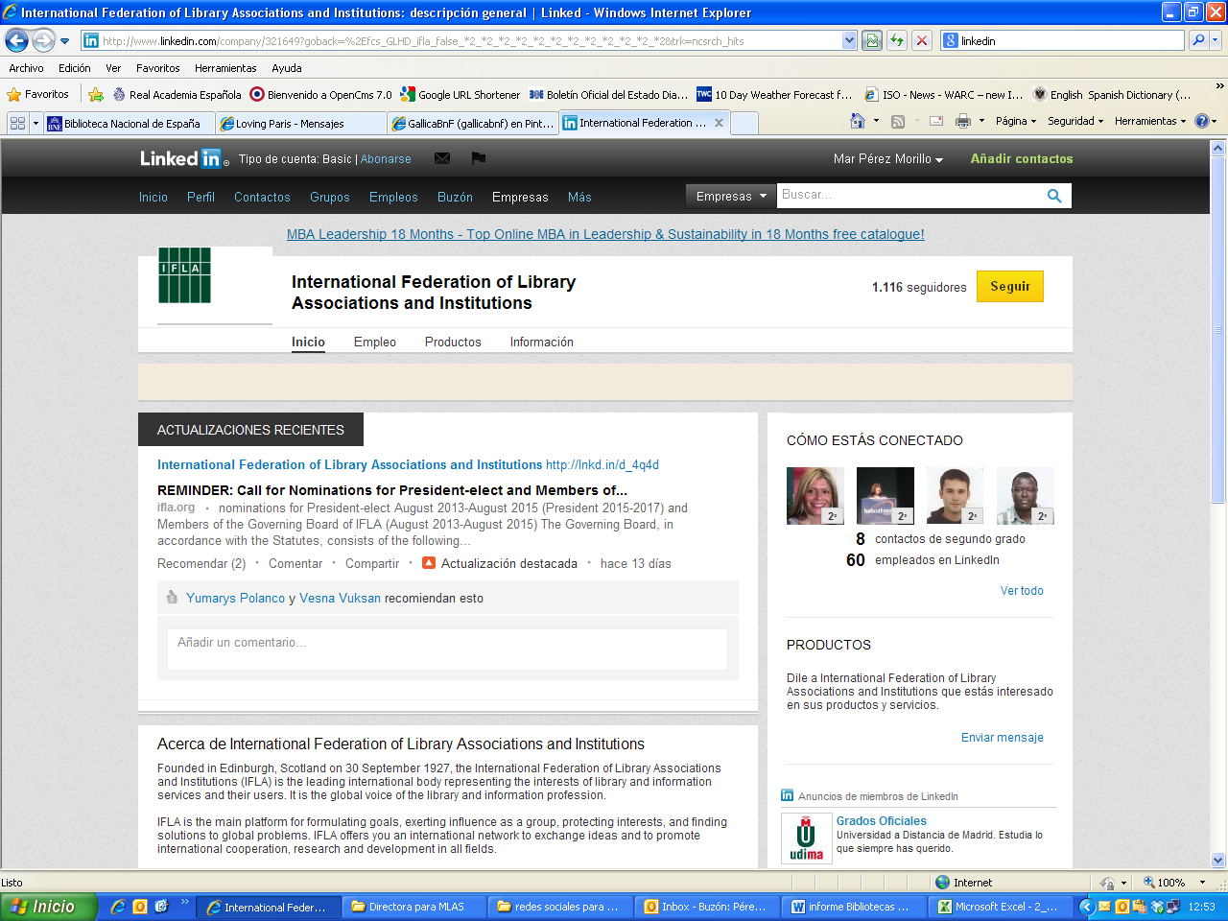

Both environments still offer areas for exploration to libraries and associations, in their search for new spaces offering any opportunity to disseminate information, enable contact between professionals and knowledge sharing.

The experience of the Biblioteca Nacional de España
The National Library of Spain set out its path in the 2.0 web with the launching of a blog in April, 2008, and a Facebook profile in November, 2008.

Three months later it already had 1,000 followers. And in May, 2011 the number reached 100,000.
Today, the NLS is the national library with the highest number of followers. Close to 129,000.
The growth and success of Facebook is an example of the impact of the web 2.0 in library organizations.
Facebook allowed the NLS to definitely become open to its remote users. Through this window we have brought our users closer to internal processes (such as the annual counting, exhibition set-ups, digitization of collections...), not publicly visible before then. We have disseminated activities, collections, documents... and, despite showing a downward trend compared to other channels such as Twitter, Facebook keeps on growing and generating traffic to other online library channels like Slideshare, YouTube or Flickr.
The channel opened in Youtube by the NLS in 2009 has helped us promote audiovisual material kept by the Library among its collections, as well as videos illustrating the activities of the institution (eg. digitization or binding processes), or its History. Also, recordings of events held in the Library (conferences, concerts, round tables, professional meetings...).
The Library's Flickr portal (March, 2011) lets the institution disseminate its graphic collections, and not only photographs and engravings but also other collections such as ephemera, not so widely known by the public (both general and specialised), but of great interest.
Through the Slideshare channel (march 2011) the Library has shared the knowledge of its specialists. This portal helps disseminate presentations of a varied range of subjects prepared by the BNE staff when attending conferences, or directly prepared for publishing online thus sharing knowledge with all kinds of audience.
But Twitter is perhaps the most dynamic portal managed by the Library right now with three different accounts; a general one for the Library, one for the Museum and finally, one for the Director. Each of them is focused on a specific users’ profile and a communication strategy adapted to their needs. It has seen enormous growth and the answer of our followers has been really gratifying.

The conclusions we may get from our presence in the web 2.0 is very positive and this feeling is strengthened everyday:

- It has contributed to a greater openness of the Institution to the society.
It has changed the perception of the citizens, who now feel that the Institution is “theirs” to a greater extent, being at their service as keeping and promoting common Heritage. The tercentenary slogan of the Library, celebrated last year, summarises this idea that guides us and draws the lines of our future work. "ES TUYA". It's yours.
- It has improved the external image of the Institution.
As a consequence of the above idea, the Institution has become closer and its image has improved from the citizens’ view. They are now much more aware of what we do and the Heritage we keep.

- It has increased the visibility of all the tasks carried out by the Library.
The versatility of these tools allow to show the tasks and processes through an audiovisual format (Youtube), image (Flickr), presentation (Slideshare), post (blog) or twit (Twitter), thus reaching people worldwide. The viral effect of these platforms in the dissemination of information is decisive.

- It helps make internal working processes more dynamic.
Many internal processes of the Library, little known until now, have been made public and shared with the citizens through the 2.0 channels. This provides feedback from users to the professionals that perceive interest for the tasks that are developed in the institution and they are more aware of the information needs. This way, the work is enriched with the motivation of the external answer. The Library professionals are aware of the interest that their activity and their specialised knowledge create among citizens.

- It opens new investigation fields to researchers by disseminating little known collections (i.e. Ephemera).
Thanks to these tools, tasks and collections less known have been promoted and they are particularly interesting subjects for new investigation lines.

- It has allowed us to better understand and answer our users’ needs with regards to both information and services.
In line with this idea of dynamization of internal processes, feedback from users helps refine our working priorities, according to what society demands from the Institution. This openness to Society allowed by 2.0 platforms is essential nowadays for library associations and libraries in order to accomplish their mission.

- It means a daily challenge and encourages us to improve.
In connection with above, the answer from our users draws the path for professionals in their analysis of priorities, and in the way in which we may fulfil our mission and satisfy users’ needs.

- It enables a closer contact with similar institutions, sharing knowledge and learning from them.
The growing presence of libraries and professional associations in social media and 2.0 platforms has, furthermore, another added value: through these 2.0 portals, library organizations can know better know their activities and the use of the different tools made by others, learn from each other and share knowledge. It all derives in a common benefit, in the way along the path heading for the great global library.
Channels 2.0 of the BNE:
Blog: http://blog.bne.es
Facebook: www.facebook.com/bne
YouTube: www.youtube.com/bibliotecabne
Flickr: http://www.flickr.com/photos/bibliotecabne
Slideshare: www.slideshare.net/bne
Twitter BNE: http://twitter.com/bne_biblioteca
Twitter Museo: http://twitter.com/bne_museo
Twitter Directora: http://twitter.com/bne_directora

Data from 20013/08/02.
There is an EBLIDA News page, but with no followers.
There is another page on Facebook with the same name, no image and 227 followers.
There is a community from the Deutsche Nationalbibliothek in Frankfurt with 239 followers (http://www.facebook.com/pages/Spotted-Deutsche-Nationalbibliothek-Frankfurt/509006392476767?fref=ts) and another one in Leipzig with 26 followers (http://www.facebook.com/DeutscheNationalbibliothek?fref=ts#!/pages/Deutsche-Nationalbibliothek/222031657811139?fref=ts).
Le Labo de la BnF es un sitio web experimental dedicado a las nuevas tecnologías de lectura y escritura (http://labo.bnf.fr/html/accueil.htm), que tiene su propia cuenta en Twitter.

