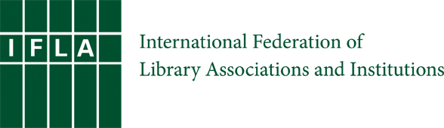
IFLA Section on Education and Training 40th Anniversary:
PHOTOGRAPHY COPYRIGHT RELEASE FORM

I, ____________________________________, hereby grant permission to IFLA’s Section on Education and Training (SET) to reproduce any portion of the photo images listed below that have been taken by me or for which I have the rights, for use in their 40th Anniversary project and other SET activities.

Permission granted for photographs listed below:
1.
2.
3.
4.
5.
NOTE: Continue listing here or at end of document.

I hereby give permission for IFLA’s SET to use the photographs for the following:
- Any form of publication approved by SET, OR (select from below)
- IFLA SET Website
- SET 40th Anniversary Book
  - Digital Format
  - Print Format
- Flyers/Advertisement for SET 40th Anniversary activities
- Other SET-approved communication

The photographs may be used, displayed, copied, edited, reproduced, posted, published, exhibited and/or distributed in any form, including, but not limited to electronic, print, digital, and/or electronic publishing via the Internet, unless otherwise noted below.

I would further like to establish the following restrictions, if any (time limit, etc.) on selected or all photographs:

I further acknowledge that my release of these photographs is voluntary and that I will not receive financial compensation of any type with the publication of these photographs by IFLA SET. I acknowledge and agree that publication of said photos confers no rights of ownership or royalties whatsoever.

_______________________________________________ ___/____/______
Signature Date

