TenThirteen -A library for all senses

Amanda Stenberg
Coordinator TioTretton
Kulturhuset, Stockholm
Stockholm, Sweden
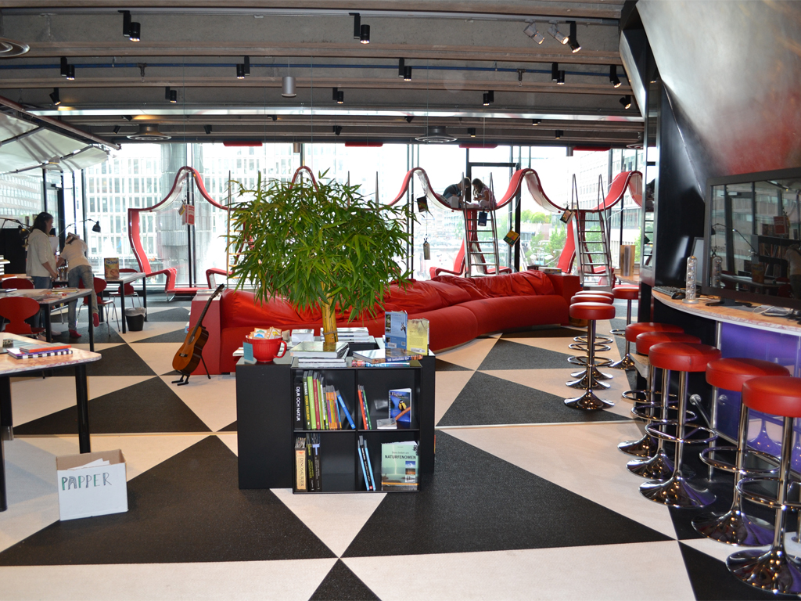

TioTretton, Swedish for TenThirteen, opened in February 2011 in Kulturhuset, the House of Culture, in Stockholm. It is the first library in Sweden, and as far as we know in the world, exclusive for children between ten and thirteen years old. This means that parents, teachers, and children not between ten and thirteen are not allowed in.

As a library our overarching concept is stories and storytelling. But there are many different forms and ways to experience or tell a story. It can be found in a book, a song, a movie, in a plate of ravioli or come to life in a discussion. In our library we embrace all forms of creativity and do not assign them any internal hierarchy. Therefore our library includes a large kitchen, a music studio, a theatre and a computer lab.
Our books are placed in every corner of the library. The most popular activity by far is reading. Lots of creative possibilities does not compete with reading, but complement it and offers new ways to approach our books and new visitors to find our library.
We work according to the idea that our library will never be finished. It is a working process where we continually try new things and involve our visitors in exploring what a library can be. As staff our most important job is to interact with our visitors. To make sure that all of them feel that our library is a place for them whether they want to find a new fantasy novel, make an animated movie, talk to an adult about life and love or just curl up in a sofa and do nothing at all.
When we opened we decided to have as few rules as possible. As long as our visitors respect themselves, others and the space they can do practically what ever they want. In trusting our visitors we want to create an atmosphere of respect not regulations.
In the mornings we work with schools in Stockholm in order to reach children from as many different areas as possible. Our library is a place for everyone; therefore our activities are always free of charge. All you have to do is take your shoes off and come inside.
We want to empower and encourage our visitors to explore life and break boundaries. In order to succeed we, as a library, must do the same.

1. A library for 10 to 13 year olds.
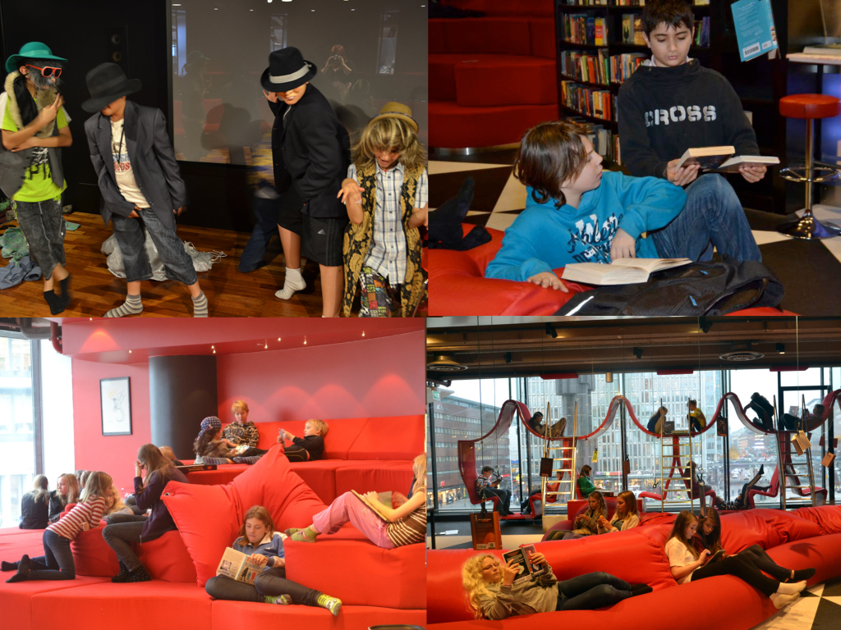
TenThirteen, opened in February 2011 in Kulturhuset, the House of Culture, in Stockholm, Sweden. We are library exclusive for children between ten and thirteen years old. This means that parents, teachers, and children not between ten and thirteen are not allowed in.
The idea to build a library for ten- to thirteen year olds came from the fact that these children did not visit the existing in-house children’s library, Room for Children, on their free time. They came on booked school visits, but not in afternoons and weekends.
This age group is often caught in the middle. Defined as leaving childhood and at the same time moving in to their adolescence, libraries often let them go to the children’s section or the youth section. We wanted to build a library where they don’t have to go anywhere. Where they can be as playful and as mature as they feel like.
A feasibility study was carried out together with the Centre for the Studies of Children's Culture at the University of Stockholm. Through interviews and surveys, children were involved from the very beginning in shaping this library.

So what did they want? They wanted music, books, a kitchen, computers, and a swimming pool. But most of all they wanted a place of their own with adults who had lots of time to talk and hang out.
After the study was done we had to wait a couple of years but then in 2011 we could open. We are opened in the afternoons from 15.00 – 19.00 and on the weekends from 11.00-17.00. In the mornings we work with schools in Stockholm in order to reach children from as many different areas as possible.
2. A library for stories and storytelling.
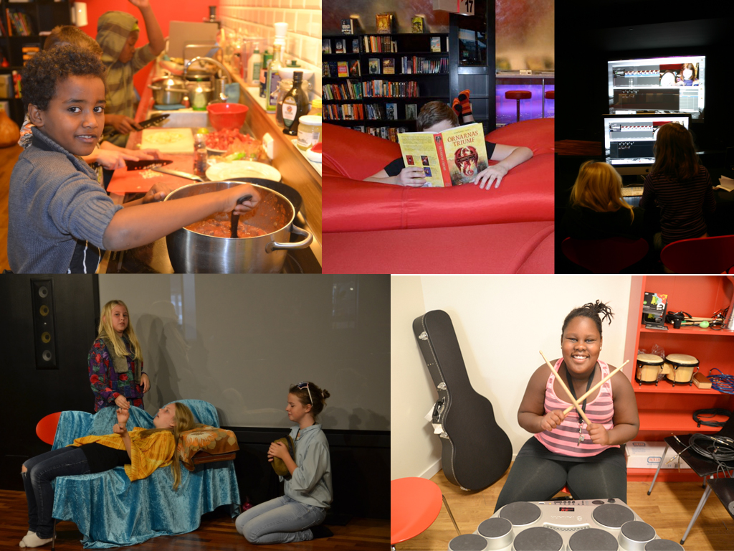

Our overarching concept is stories and storytelling. But there are many different forms and ways to experience or tell a story. It can be found in a book, a song, a movie, in a plate of ravioli or come to life in a discussion. In our library we embrace all forms of creativity and do not assign them any internal hierarchy. Therefore our library includes a large kitchen, a music studio, a theatre and a computer lab. We wanted to build a library that would attract all children, including those who might not normally visit the library.
It is our goal to create a place where our visitors can find at least one thing that they like, and that this will give them the confidence to try new things.
This also means that we ass staff need to put ourselves in situations that we do not fully master. If we are serious in creating an environment where want our visitors to try things and for them to feel that the result is secondary we need to live as we learn. For example it can be a point that the person leading a workshop is not an expert in the field, in order to create an atmosphere in which we learn together.
We are six people who work at TenThirteen, all of us with different backgrounds, from a drama teacher to a political scientist, a musician, a librarian, an artist and a museum worker. This mix of people and areas of expertise allows for new and unexpected methods and ideas to emerge.
We have learned a lot of things during our first year. For example when we opened we thought that we had to offer activities all the time for the children to visit us. But we soon realized that what most of them wanted was a place to relax, breath, read and just hang out.
This shapes they way we work. We always keep material and equipment on the tables for our visitors to feel that they can start anything without asking. When, and if, they want help we are there.
2. The Library as an oasis
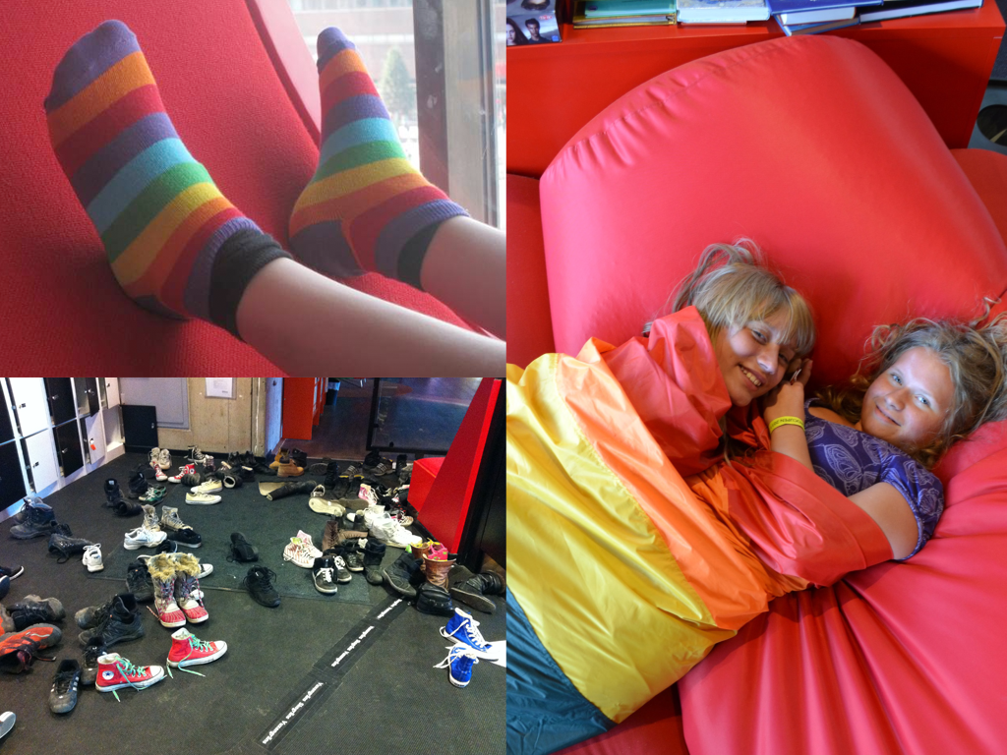
One of our strategies to create a library oasis is to have a a line. A line that only children between ten and thirteen can pass, if they take their shoes off. Before we opened we wondered a lot about how this idea would work in practice. Would the parents get angry? Would the children be allowed to come? How would they interact with each other and with us as staff without their parents? As it turned out we did not have to worry at all. Not only have both parents and children embraced this border, but also it is in many ways the prerequisite for the way we work.
We want to create a library oasis for our visitors in which they can be just as active or passive as they like. Where they don’t have to produce anything or live up to an image. Parents sometimes have one view of what their children are like and what they for example like to read. We want our visitors to have the possibility to, on their own terms, shape their visits.
Consequently, we as staff are the only adults in our library. This gives us the opportunity act as the third adult. Not being a parent or a teacher we can meet our visitors just as they want to be met that day. We are there to listen, to talk to about books, assist them in their creative process or just hang out with.
When we opened we decided to have as few rules as possible. As long as our visitors respect themselves, others and the space they can do practically what ever they want.

3. Stories through books
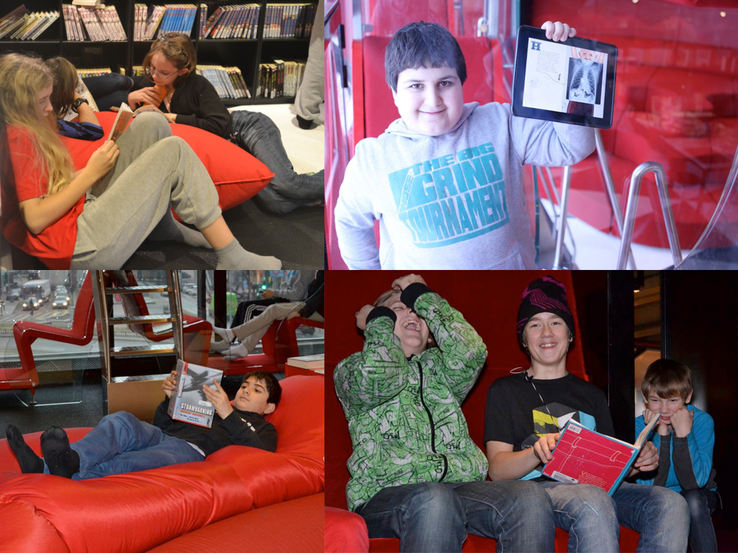
Our books are placed in every corner of the library. The most popular activity is reading. Lots of creative possibilities does not compete with reading, but complement it and offers new ways to approach our books and new visitors to find our library.
We have visitors with all kinds of feelings towards reading. Some who love to read and devour books and some to whom books are associated with obligation and page counting. Our role as staff is to make sure that in our library, reading is something personal and not measured in pages or amount of words. You can take home ten books and not read any of them and if you start a book and do not like it, it is more than okay to stop reading.
We also try to involve our visitors in deciding what books to fill our library with. If they find a book that we do not have we buy there and then. We have different ways to post suggestions on what books to buy, online and in our library. But we feel that the best way is to go straight to the computer in the library and let the visitor see that we are actually buying the suggested book.

4. Stories in the kitchen
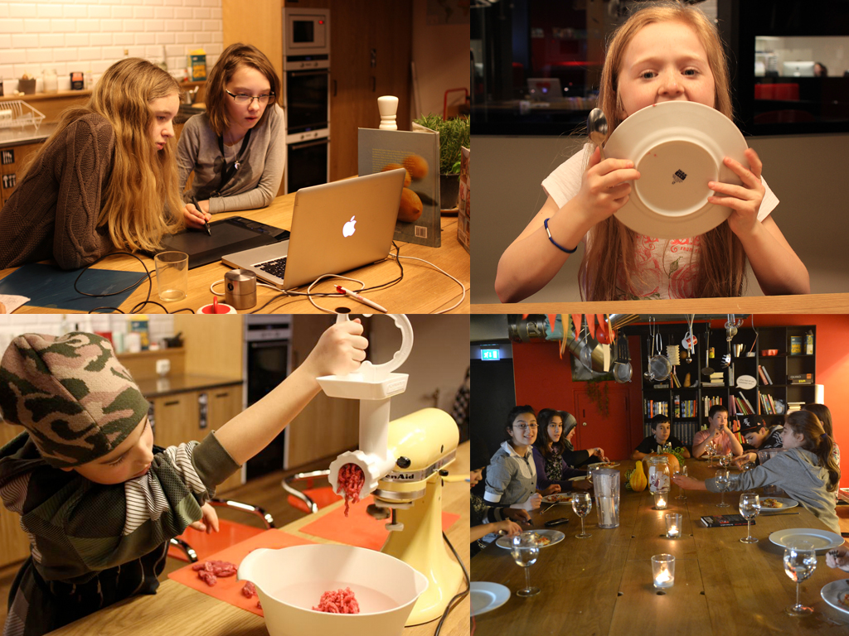

A kitchen might be an unusual part of a library but it is not an unusual part of our lives. The kitchen fills the same purpose in our library as it does at home. It is a place to sit down together, do homework, talk and share stories.
One of the things we want to encourage and prioritize is the meeting, meeting between our visitors and meetings between us and our visitors. The kitchen is a perfect place for this.
Cooking is also a way to create stories through experimenting with flavors and ingredients. It is also one of the best arenas to experience that things do not always turn out as you indented, but might turn into something else.

5. Stories through film and music
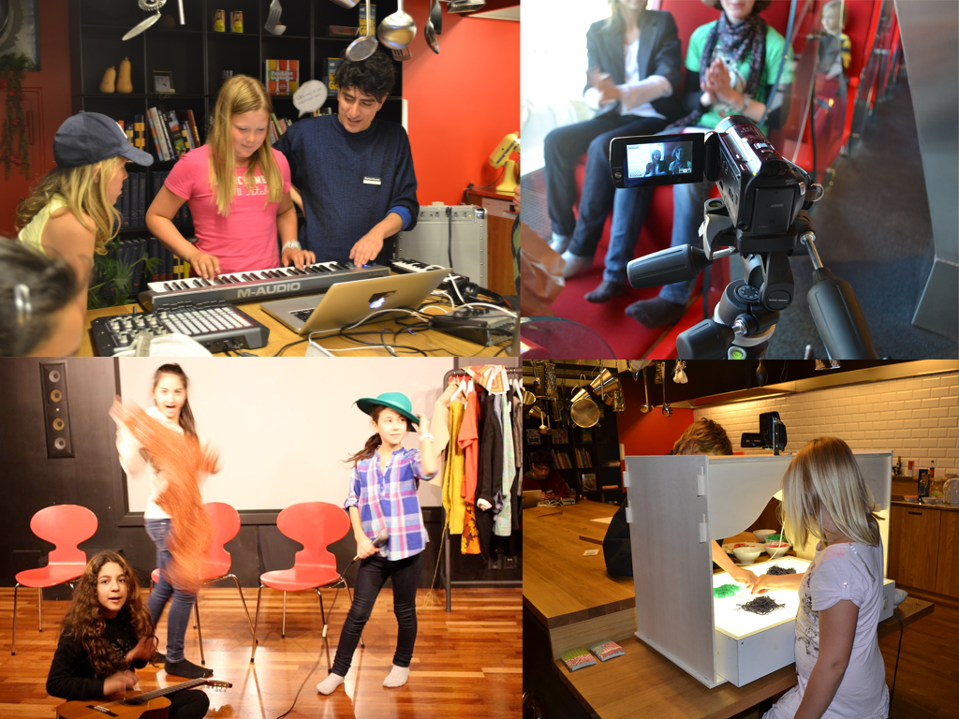

Acting and creating music is an important part of our library. Showing our visitors shortcuts and digital possibilities to create sounds and beats. You do not have to know how to play the guitar in order to create a song. We stay away from dividing our tools and methods in digital and traditional, most of the times they go together. You may start an animation with building figures in clay and then finish the movie in the computer. We always try to keep a very playful attitude towards our digital possibilities; a lot of digital equipment can be a bit daunting if you are not familiar with it. We want all of our visitors to have the opportunity to approach new technology in a creative and fun way,

6. Conclusion
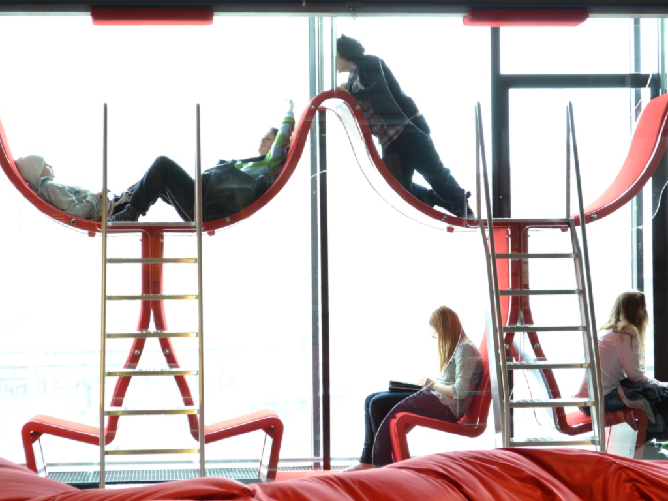
When you are ten to thirteen years old you have many questions and thoughts about who you are, who you want to be and who you might be. We try to create a library in which you can find perspectives, angels, ideas, thoughts and meetings to help our visitors shape the most important story of all. Their own.

