Popcult – the revenge of the nerd library

Stig Elvis Furset, Buskerud county library/Drammens library, Drammen, Norway

Popcult has broken new ground on the library services towards teens, young adults and adolescents by their focus on popular culture and nerd culture. Their target group are everyone, whether one is 15 years or 25 years old, who are interested in sub- and popular culture. By doing so, they have also tried to break down some of the age barriers between young adult and adult material. They have earned widespread recognition in Norway, especially with their gaming events, and are now involved in building Popcult departments in the libraries in the cities Fredrikstad and Molde.

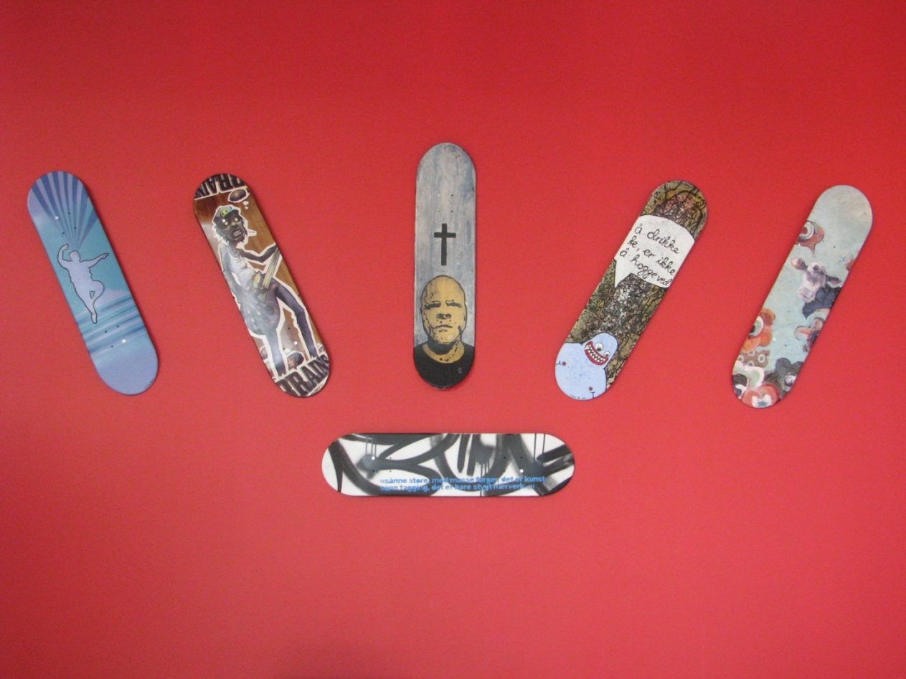

Are teens and young people the group that all libraries are yearning for? Maybe so. But why are the commitment for libray services for young people then on a minimum level? The average library facilities for this group have looked like this in Norway:

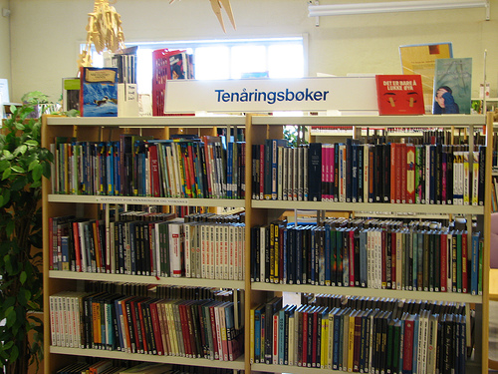

It's a really small place in the corner of the room, which most often is called "the teen corner". The teen corner concists of a couple of shelves, full of so called "youth books" or "books for young people" only, and with the spines of the books pointing out in the room. Some worn out comic books are located in a small box on the floor. The furniture are dominated by a sofa full of holes, linked to the strange idea, which no one knows where come from, that the teen corner in a library must have a rustic and sort of worn out style.

Or maybe some shelves will do the job. This is a picture of my own library, Drammensbiblioteket/Drammen library, the way the teen corner looked on the opening day of the brand new library in march 2007.

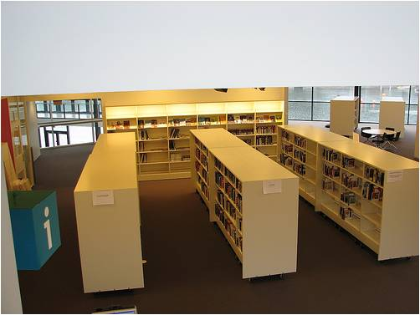

When the library building was planned absolutely no profound thinking was done on the services towards the young adults. None. Which was rather normal at the time. And maybe still is? If you get a job as a childrens and youth librarian today, it's expected that your main focus are on children. Librarians occupied with the services towards young people hardly exists at all. Maybe it's time we take a different attitude towards the "youth problem". In my opinion, the distinction between the childrens and youth services should be widened. A childrens librarian are not a youth librarian, and the other way around. And shall not be.

If we look upon the average 15-year old youngsters cultural interests, he or she has more in common with the 25-year old, than a child at five. Or the 20-year old, than a tween at ten. And still we see children and teens as one. No wonder that many libraries are irrelevant for this age group.

But it's the essence of what Popcult at Drammen are all about. The Popcult-department have since it's starting date in 2008 become the most successful project at the library. And one of the main focuses have been to break down the age barriers between teens/young adults and adults.

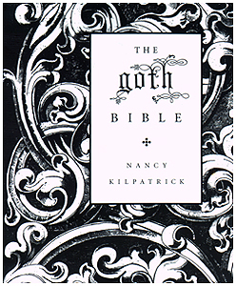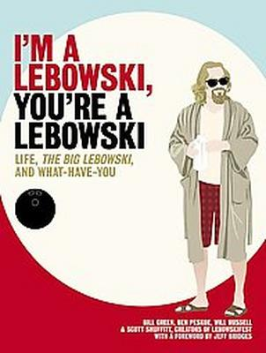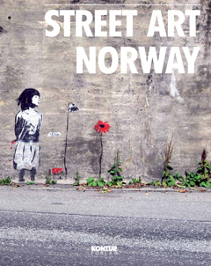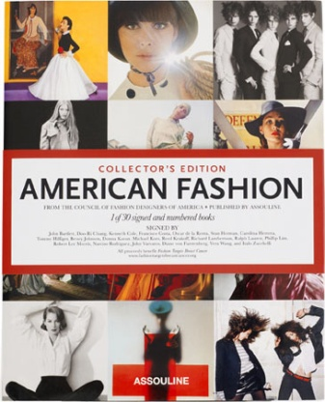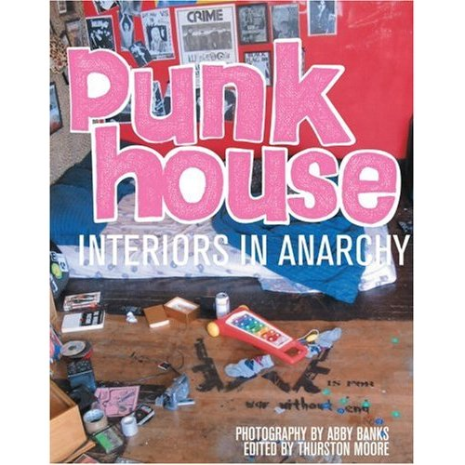

The juxtaposition of the words is a signal of two things in our basic ideology. Pop means that popular culture are a dominant part, both in the chose of material and in the building of the area. Cult doesn't mean cool. Cult means that the material also can have a flair of underground culture. Or subculture may be a more precise word for it. We lean upon tearms as cultbooks, cultfilms, cultbands etc. Phenomenons which may not be widespread in the cultural field, yet, but have a small but extremely dedicated base of followers.

Concerning age groups: Popcult in not meant to be a service towards teens and young adults in the traditional librarians point of view. Popcult has a more wide-spread target group than teens. In fact, we don't think much about age at all. Our target group in the choice of material are everyone which is interested in sub- and popular culture, independent of age.

Taking this into account, we do not look upon young people like unified group, that we will be able to reach out by playing on some pseudohip youth codes. Our main focus are primarily directed towards the nerds and the geeks, not at least when we plan the events for the season. And by doing so, we have experienced that we have a loyal and steadfast following at the different events.

In our literature promotion we work towards to integrate the typical "youth literature" or "young adult literature" with the adult literature and material in Popcults profile. We have experienced if you put the "youth mark" on literature, by telling both teenagers and adults alike that this is literature made for one special age group, they probably will turn their backs to the literature. The most avid or eager readers move directly from the childrens department to the adult shelves. We see the same in the other media as well. Although they are teens, they don't like to be treated like that. They feel stigmatized. So, when asked, I've often heard them say that "youth literature" are written by adults who are trying to hard to get in touch with them. They're wrong, I know. But we are doing it difficult for ourselves to promote these books by labeling them with the "youth" term. Our thesis is that tese books will reach a broader reading segment if they are integrated in other literature. And then labeled into themes or genders, not how old you are.

I will mention one example from the shelves from the recent years which illustrates what the ideology behind Popcult is all about. You have all heard of it: The Hunger Games.

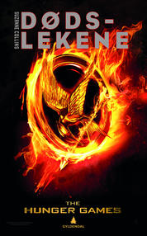

When the first book was translated to Norwegian as early as in 2008, almost no one noticed. It went under the radar, so to speak, apart from a small group of teenagers (and librarians) which went headstrong into the universe, and started raving to others about what they have read. These teenagers were the nerds and geeks. Those who let their love affair with a cultural product transcend all media plattforms, and who are not finished with a book when they are on the last page. No. They start acting out their fandom. Either by dressing up as the books different characters, write fanfiction based on the universe or make you tube-videos about various aspects of Hunger Games' content.

Today, four years later, The Hunger Games have crossed over to the rest and become something which are on everyones lips and reading lists. I believe we should not underestimate the role that the geek-culture has played in the creating of this global phenomenon. If the libraries create close contact with this culture, one will be able to foresee trends and tendencies in the cultural field before they become common property.

And by becoming common property we see that Hunger Games, like Harry Potter, has crossed the age boundaries surrounding young adults novel. Adults have started asking for them, and other books which deals with a dystopian society. This spring, even the tabloid media in Norway wrote about what's happening to the young adult books when they appeal to the adults. Maybe they have become tired of mediocre crime. For more than any other genre, todays literature for young adults deals with our own times. By that reason alone, I believe we shall welcome the adults readers into our field. One of Popcults aims are definitely to do so.

We seek to offer an eventful and contemporary cultural experience, and our gaming nights has become a sort of flagship in that part.

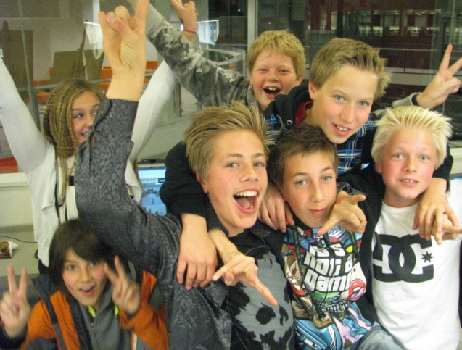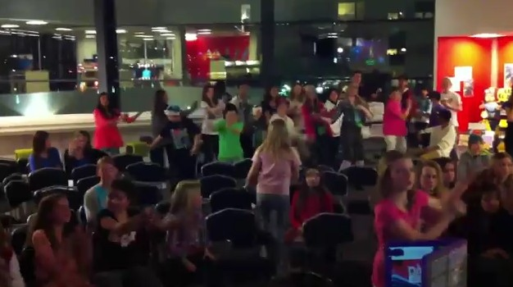

The Gaming Night, or "Spillnatt" in Norwegian, is held twice each year. And as the name states: we open up the library at 19.00 pm on a Friday and closes late at night. The first couple of years it did go on until the next morning, for twelwe ours, but … yes, both we and the kids became too tired, so now we closing time is approximately 02.00 a.m. Last autumn we held our ninth Gaming Night, so we have developed a lot of experience during the years. And one of the most important experiences are that the social aspects of the event are very important for the kids. Every Gaming Night have been completely sold out (120 tickets on the most), and the kids start immediately ask for when the next event will take place when it's over.

Due to intake of sugar, the energy level can be very high, but there has fortunately not been many accidents. One broken arm since 2008, that's all.

With the Gaming Nights we give them a whole new understanding of what a library can be and mean to them. And one aspect there are very important: we don't smell like school. Popcult are probably the only library service towards youths that does not seek cooperation with school in any kind. Why not? Because cooperations between libraries and schools, at least in Norway, always ends up with that the library yields or produce, while the school derives and profits. That's not cooperation …

Many have asked us about this. Are we just a leisure-time club dressed in a libraries clothes? Are we unfamiliar with learning? Not at all. To gain a wider knowledge of different things and matters exists in all our events.

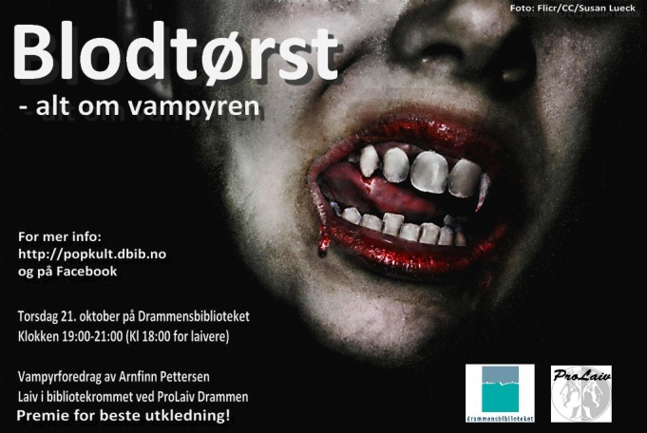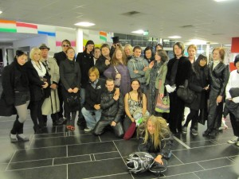

Of course, we have been doing vampires. In the event "Bloodthirst" we hired folklorist Arnfinn Pettersen (who dressed up as Van Helsing) to do a talk about the vampires recurring impact on our culture. Surprising to us: He and the youth found each other right away in a common contempt towards the sensitive Twilight-vampires. Afterwards there were a mini role-playing vampire-game among the shelves.

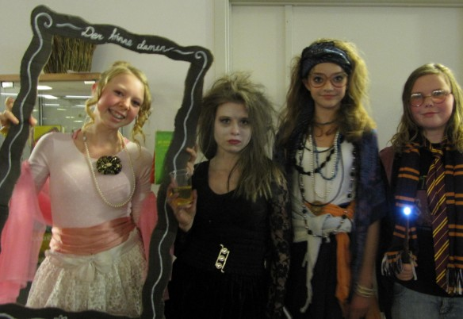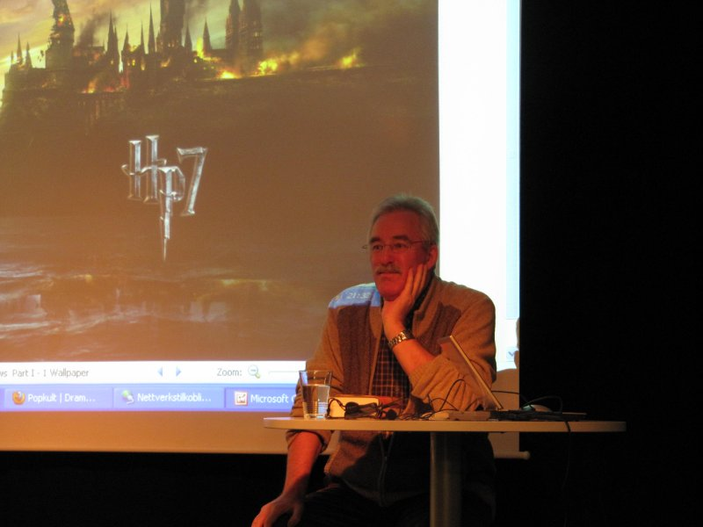

In connection with the midnight world premiere of the last Harry Potter-movie we cooperated with the cinema in Drammen, and arranged a pre-party gathering in the library. The translator of the books in Norway, Thorstein Bugge Høverstad, did a talk about his work. And it's a very special phenomenon that a translator of novels has something that resembles a star status among the youth. That tells us something about the dedication among the Potter-nerds.

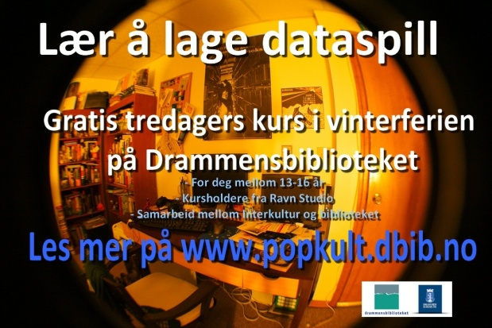

A lot of libraries arranges workshops in creative writing. In Drammen we are so lucky that one of the best producers of video games, Ravn Studio, are neighbours with the library. So during the winter holiday, they held a workshop in the making of video games. Of course, not many libraries have this opportunity, but anyway: the important thing is to seek out the different creative environments in your surroundings.
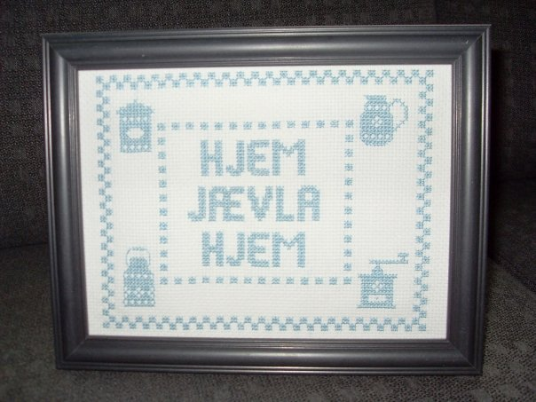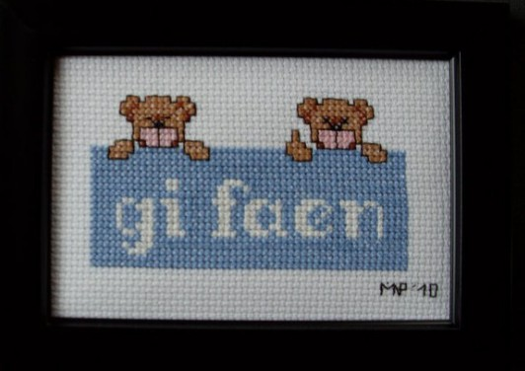

How eccentric is it possible to be? Our workshops in aggressive cross-stitching are small-scale events. The participants receives a tool-kit and ideas on both how to draw patterns and different texts to cross-stitch into this otherwise cozy art-form. Like "Home Bloody Home". To attend this workshops is sort of passive-aggressive … with a redeemable flair I'm told …

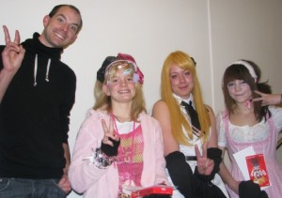

The last event we have hosted, by public demand, was an evening were the theme was Japanese culture. Former comic book-editor Hans Ivar Stordal talks about mangas impact in the Japanese society, and was also a judge in the cos play-competition afterwards.

In Norway it's a rather risky task to hold events for the youth in library. How many will come, if any? We have asked us this more than once. We didn't have to worry. The geek-teens are marvelous at spreading the word among themselves. And so far there have been no competition. No other institutions have this youth group as focus-audience.

Media/Genre
Popkult 2,02
Video Games 36,01
Fantasy 1,71
Young Adult 2,06
Comics/Graphic Novels 3,77

Some statistic. The circulation numbers are quite good. After an extradordinary top of 4.2 among the Popcult books the first year, they shrank the year afterwards, also due to an increase in the material, and are now on 2.02. And there have been a small, but steady increase the last years. The comics are higher, with the circulation number 3.77. And of course, no one can beat the video games, which are on 36.01.

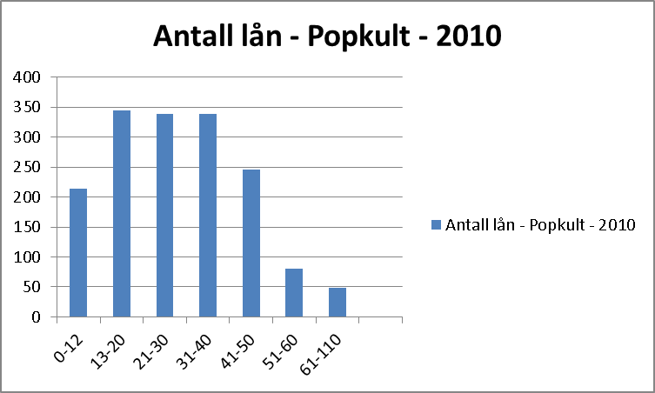

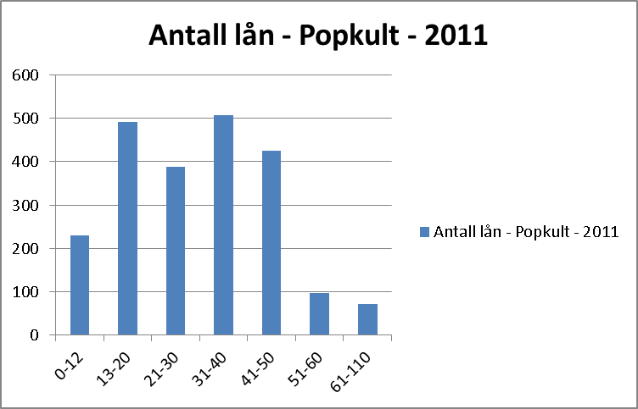

But well as interesting: which age groups use us? Here we face some challenges, especially among those between 20-30. Since we are a joint library with a college library, there are a lot of students in the building each day. They have not discovered us yet. We did a survey among them, and we learned that our branding had to be better. So three students at the department of visual communication at the college did a paper on Popcult as their bachelor-grade, and came up with this logo for us last year, with a package of different promo products as well. And its working.

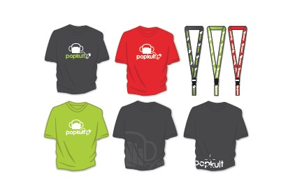
Popcult has earned widespread recognition in Norway. We are now involved in building Popcult departments in the libraries of Fredrikstad and Molde, with fundings from The Norwegian National Library.

And it's a whole different attitude towards the youth in the library field today than it was a couple of years ago. In all modesty: Popcults effort at Drammens library has played an essential part in this.

Together with the nerds …

Thank you!

